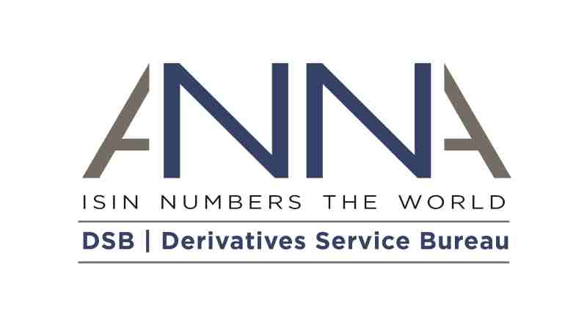

Derivatives Service Bureau

2020 Consultation

Industry Consultation Paper 1

Published 9th May 2019

Contents
Executive Summary 3
Respondent Details 3
Consultation Timeline 4
Principles 5
Utilization of the DSB 6
Consultation Questions 8
Section 1: FUNCTIONALITY 8
Section 2: DATA SUBMISSION ENHANCEMENTS 12
Section 3: SERVICE LEVELS 17
Section 4: SERVICE AVAILABILITY 18
Section 5: CYBERSECURITY 19
Section 6: AOB 22

Executive Summary

Industry feedback is sought on questions that will shape the DSB service in 2020.
The questions contained within this consultation are based on queries and feedback received from industry since the DSB’s consultation in 2018. As with prior years, the purpose of this first consultation is to obtain industry’s view in order to ensure that the DSB focuses its attention on those potential changes which are the most valuable.
The features identified as most desired by industry (from this first round of consultation) will be subsequently analyzed in greater detail. Associated detail on costs and functionality will be provided as part of the second consultation round to allow industry to provide feedback on whether it wishes the DSB to proceed with implementation in 2020.
Proposed Format for Industry Responses to the DSB Consultations
- Consultation responses should be completed using the form below and emailed to industry_consultation@anna-dsb.com
- An option is provided for respondents to stipulate whether the response is to be treated as anonymous. Note that all responses are published on the DSB website and are not anonymized unless a specific request is made
- Where applicable, responses should include specific and actionable alternative solution(s) that would be acceptable to the respondent to ensure that the DSB can work to reflect the best target solution sought by industry (within the governance framework of the utility)
- As with prior consultations, each organization is permitted a single response
- Responses should include details of the type of organization responding to the consultation and its current user category to enable the DSB to analyze client needs in more detail and include anonymized statistics as part of the second consultation report
- Responses must be received by 5pm UTC on Wednesday 5th June 2019
- A webinar to address consultation related queries will take place on Thursday 16th May 2019. Register for the webinar here.
- All consultation related queries should be directed to industry_consultation@anna-dsb.com

Respondent Details
Name
Email address
Company
Country
Company Type | Select Type
User Type | Select Type
Select if responses should be anonymous | ☐

Consultation Timeline
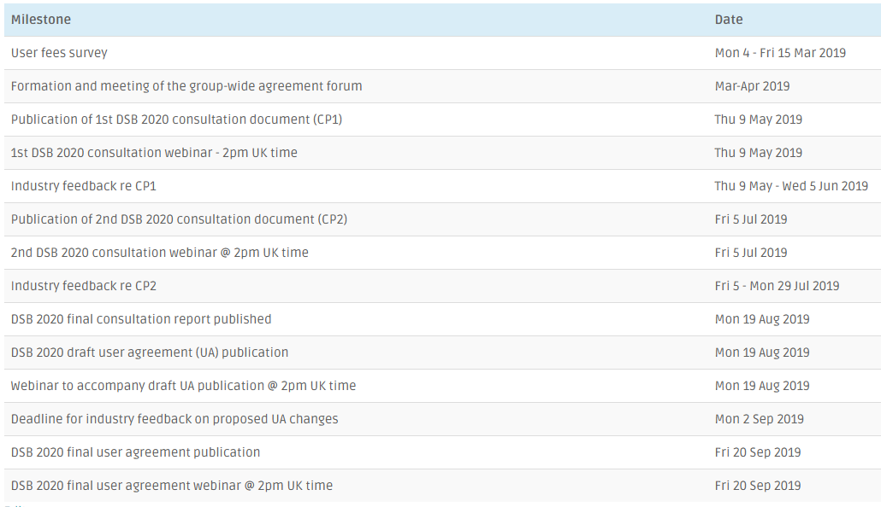
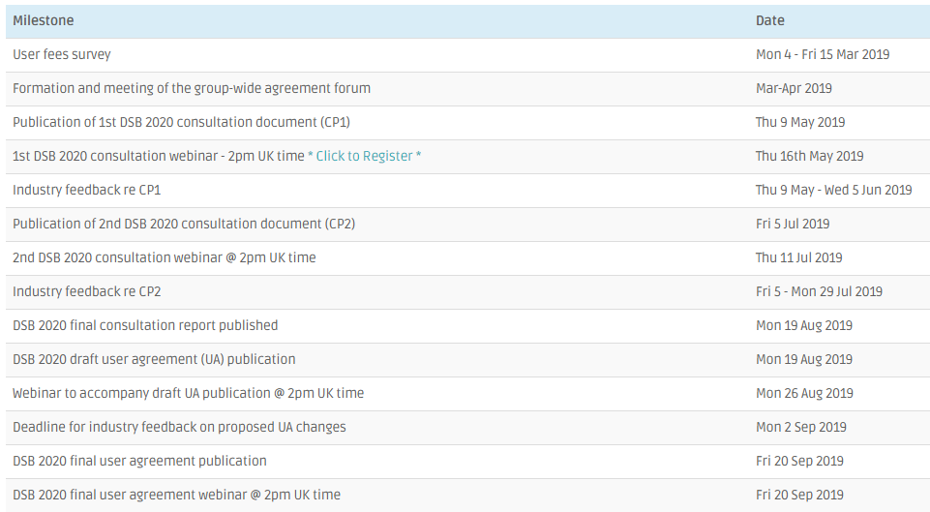

Principles
The table below provides an overview of each of the four key principles used by the DSB when developing the fee model.
Principle | Brief Description
Cost Recovery | The DSB will provide all numbering agency services on a cost recovery basis.  From the DSB’s perspective, this means that the revenues must be sufficient to ensure that the numbering agency has the financial viability to meet its continuing obligation to provide these services.  From the user perspective, it means that the payment for these services does not profit the owners of the utility beyond its maintenance as a financially viable entity.  Furthermore, the funding model needs to be sustainable, which includes the need to be efficient and reliable.
Unrestricted Data | The DSB intends that no data associated with the definition of an ISIN will have licensing restrictions dictating usage or distribution.  If the DSB Product Committee (http://www.anna-web.org/dsb-product-committee/) determines that there is no viable alternative to the use of licensed or restricted data in a product definition, the DSB will review the impact to its Unrestricted Data policy at that time, taking into account the specific products and attributes that are impacted by the incorporation of licensed or restricted data in the product definitions.
Open Access | Access to the DSB archive for consumption of OTC derivative ISINs and associated reference data will be available to all organizations and users.
Payment in Advance | To the extent possible, the DSB will levy fees through annual contracts that require payment in advance.  This advance yearly commitment offers the DSB more clarity in aligning fee levels with cost recovery.  For the users, it provides improved ability to forecast their costs for utilising ISIN services

Utilization of the DSB
In 18 months of service, 118 fee paying users have created over 21 million OTC derivative ISINs, with the sell-side driving the vast majority of ISIN creation activity and over 420 firms directly consuming OTC ISIN data – via access to end of day data or searching for OTC reference data information.
The DSB launched its production service with 83 product definition templates available for use, expanded to 87 product definitions by year ending 2018, added a further 6 templates in Q1 2019 and has received Product Committee approval for the introduction of at least 3 additional instruments in Q3 2019. Such developments allow the DSB to remain aligned with product evolution in the OTC derivative markets – with expansion at direct user request.
As set out in recent DSB blogs, the DSB serves two distinct category of users – the OTC record creators (table 1) and data consumers (table 2) who access the DSB for end of day data and/ or search the DSB for all or part of the OTC record (which contains the OTC ISIN, the CFI, the FISN and the full set of associated user input and derived attributes).
Table 1 (for ISIN creation activity) shows that the vast majority of data is produced by the sell-side, with the data in table 2 highlighting the comparatively broader range of data consumers, who comprise over 70% of all firms acceding the DSB’s services. Readers seeking further detail underlying the data shown below are encouraged to review the DSB Blog available here.

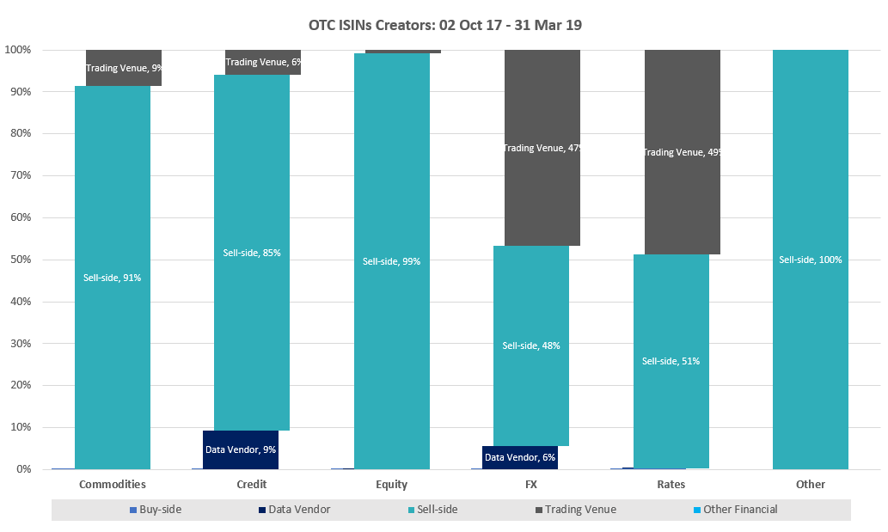
Table 1: Types of firms creating OTC ISINs and/or CFI codes

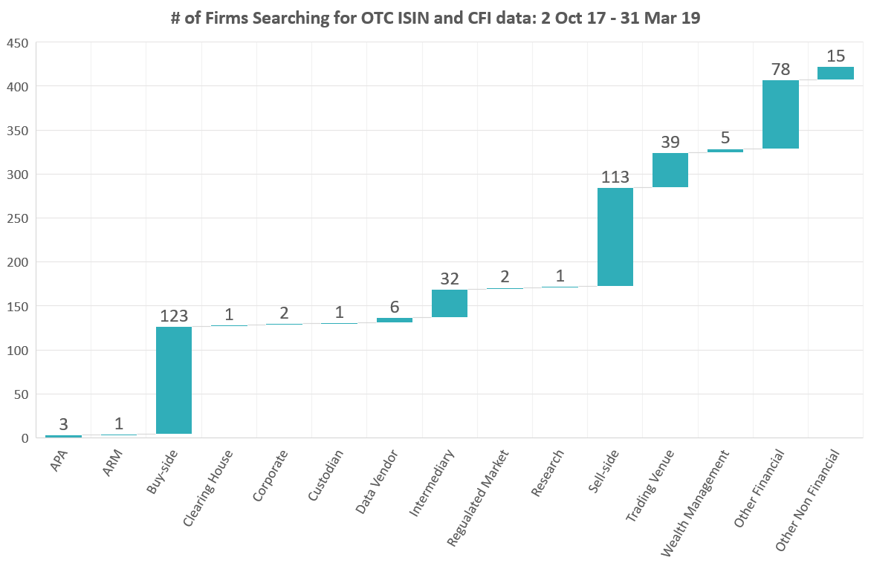
Table 2: Types of firms directly connected to the DSB to search for OTC ISIN and CFI data
As table 2 shows, with over 420 firms connected to the DSB and 118 paying to use the service, most DSB users connect with the service free of cost to search for and download the machine-readable OTC record for use in their internal systems.
The DSB was set up to provide an OTC ISIN and the associated ISIN record to facilitate reference data reporting, a part of MiFID ii. In addition to offering OTC ISIN data, the DSB has also provided CFI codes within each OTC ISIN record – with use of the CFI garnering increased interest from the sell-side and a growing driver for the additional product templates being provided by the DSB.
2018 was a busy year for the DSB, with the following changes delivered to market and the results of last year’s consultation have in turn fed into the DSB’s 2019 book of work. The DSB delivered the following in 2018:
- 10+ major service enhancements including delivery of ToTV functionality for non-OTC ISINs
- 9 product templates launched
- 3 rounds of industry consultation delivered in alignment with the announced timeline
- Introduction of 24-hour turn-around for proprietary index availability
- Introduction of the DSB Challenge and Change Request Process
- Review of work to support RTS-23.Field 41 enhancements required by ESMA, including creation of a Field 41 FAQ document and a request for the development of a tenor calculator to facilitate industry consistency in broken-dated scenarios
- Proactive enhancement of various data validation and enrichment rules
In light of the broad spectrum of institutions utilizing the DSB, it is hoped that a representative set of firms will seek to respond to this consultation. All responses should be submitted to the DSB Secretariat at industry_consultation@anna-dsb.com no later than 5pm UTC on Wednesday 5th June 2019.

Consultation Questions
The following questions focus on areas of service and functionality including data submission processes, service levels, service availability and cybersecurity where user feedback and requests have been received since the DSB’s annual consultation in 2018.
In March 2019, the DSB conducted a user fee survey to garner user views on the existing fee model timeline and annual review cycle. The survey was designed to allow DSB users an opportunity to provide early feedback that could feed into the DSB’s Group Wide User Agreement Forum and downstream consultation processes.
Reviewing contracts for group entities currently with multiple licenses, while maintaining the DSB values of representation on a fair and equitable basis within the OTC ISIN, CFI and FISN user community is a priority for the DSB. To encourage industry discussion and feedback on this topic, the DSB has extended invitations for participation in a Group-Wide Agreement Forum to discuss possible ways to enhance the User Fee model.
Given the parallel work on user fees and DSB Access and Usage Agreement, together with the feedback from this consultation, a second consultation round will follow providing further details on the proposed functionality and costs for the 2020 service provision.
The questions set out below are drawn from regular user feedback to the DSB, from the DSB’s own observations in an evolving regulatory landscape and items proposed by the DSB’s industry committees.

# |  |  | Question for Consultation |  | Participant’s Response

Section 1: FUNCTIONALITY
1.1 | The DSB was originally set up specifically to generate OTC ISINs to meet industry’s needs for MiFID II RTS 22 / 23 transaction reporting.  Some DSB users have expanded their use of the DSB service for additional regulatory purposes such as generation of CFI codes for EMIR reporting. However, the DSB implementation to support EMIR has been ad-hoc and is not comprehensive, given the initial focus on OTC ISIN coverage.  The DSB would therefore like to understand whether industry would like the DSB to provide a comprehensive CFI generation service for all OTC derivative products in scope of EMIR so that CFI codes could be obtained from a central source, without the need to auto-generate the OTC ISIN or the OTC ISIN data record.  Question: Should the DSB investigate the provision of a service that supports the creation, search and publication of CFI codes for all products in scope of EMIR? Given the wider product scope of EMIR vs MiFID, the DSB envisions such a CFI service to be independent of the existing ISIN generation service.
1.2 | Users have integrated with the DSB service at varying points in the trading lifecycle from pre-trade through to post-trade, regulatory only purposes.  Some DSB users have requested that the DSB maintain and publish the mapping between each DSB product template and the associated sub-asset class as specified by the ESMA MiFID II taxonomy.  Such a service would provide a central data source for OTC derivatives users and could be maintained on an ongoing basis as new OTC derivative templates were added to the DSB (for ISIN or CFI purposes) – for use in either machine readable and/or human readable contexts.  Question: Where users are programmatically integrated into the DSB and seek to map data across a variety of regulatory reporting related needs, should the DSB investigate provision of (machine and human) readable mapping between DSB product definition templates and the ESMA MIFID II taxonomy’s sub-asset classes?
1.3 | Currently, most DSB product templates support default values for several attributes (e.g. Delivery Type and Price Multiplier). The provision of defaults is intended to support the user experience, with defaults approved by the DSB Product Committee to reflect the most commonly used values that match prevailing ISO standards.
 | a) |  |  | Does your firm use the DSB to generate OTC ISINs and/or CFI codes?
 | b) |  |  | If you answered “yes” to 1.3(a) above - do you consider that the use of default values is helpful in the creation of ISINs by the DSB?
 | c) |  |  | If you answered “yes” to 1.3(a) above – does your firm rely on the default values supplied in the OTC derivative product templates?
 | d) |  |  | Have you experienced any problems when using the default values supplied in the OTC derivative product templates? If so, please provide examples of use cases where problems have been experienced.
1.4 | Data Availability  The DSB utilizes a number of sources to support the provision of Reference Rates and Underlying Indices for OTC derivative products.  The full list of underlying indices that are supported (excluding user owned proprietary indices) are available here. The DSB currently updates its list of enumerated values as new values become available.
 | a) |  |  | Does your institution primarily use the DSB to create OTC ISINs and/or CFI codes (programmatically or via the GUI)?
 | b) |  |  | Does your institution primarily use the DSB to search for OTC ISINs and/or CFI codes (programmatically or via the GUI)?
 | c) |  |  | Do you consider that the underlying identifiers made available by the DSB are sufficient for the OTC ISINs that need to be created or accessed by your institution?
 | d) |  |  | If you answered “no” to 1.4(c) above – please provide additional sources that should be evaluated for inclusion - based on a global standard that is endorsed by the industry - and state the appropriateness of each source by asset class.
1.5 | DSB GUI: The existing DSB GUI allows users to search and create ISINs as an alternative to Programmatic APIs. The GUI create function allows users to create one ISIN at a time and the search functionality offers a range of searching capabilities for technical users who are familiar with the Lucene programming language as available here.  Please note that this query focuses on the search aspects of the service to allow for the views of the approximately 300 firms using the DSB’s GUI based search functionality.
 | a) |  | Does your firm primarily rely on use of the DSB GUI?
 | b) |  | The existing DSB GUI search utility requires a degree of technical knowledge for more complex queries. Examples of the current search functionality are set out here.  Question: Should the DSB investigate the enhancement of its web-based GUI to allow non-technical users to search for ISINs by any attribute across any product template?
 | c) |  | If you answered “yes” to 1.5(b) above - please can you provide examples of the types of queries you would need to perform through the GUI.
 | d) |  | Is the existing DSB GUI performing to industry expectations or does it need enhancement – given its role as a meaningful alternative access point?
 | e) |  | Are there any functions or additional information that your firm wishes to add to the existing features within the DSB GUI?
1.6 | The DSB’s template-based architecture is going to be subject to major enhancements over the next twelve months in support of work to provide dynamic enumeration and hierarchy facilitation.
 | a) |  | Do you think that the DSB service should be reviewed in order to examine any additional technical enhancements that could be made to facilitate enhanced and/or more efficient integration?
 | b) |  | If you answered “yes” to 1.6(a) above – could you provide any details of the changes that might improve the system and what benefits would accrue?

Section 2: DATA SUBMISSION ENHANCEMENTS
2.1 | Proprietary Index Submission Process:  The DSB currently supports a workflow that ensures that a Proprietary Index will be made available for the creation of OTC ISINs a maximum of 24 hours (if the request is submitted on a business day) following receipt of the initiating request.  This process allows users to submit indices for which they are responsible for later use as an underlying instrument in the creation of OTC derivative product records. The DSB then makes this data available via manual upload on to the DSB website, for download and consumption by users.  Any amendments to the list (once available in the DSB’s Production systems, but where the underlying index in question has not been used in the creation of an OTC derivative product record) require between two to four weeks to allow for code changes ahead of implementation.  The DSB currently updates the Proprietary Index list manually with dependency on the information provided by the users. Validation is undertaken to ensure that each index name remains unique.
 | a) |  | Does your firm make use of the proprietary index submission process?
 | b) |  | If you answered “yes” to 2.1(a) above - do you want the DSB to investigate the creation of a tool to ensure that the submitted information can be easily amended if changes are required by an institution and the underlying data element has not been used to create an OTC ISIN?  This would enable users to have changes available in a few days rather than the current 2 to 4-week process.
 | c) |  | Do you consider that there is a need for the new Proprietary Index inclusion timeframe of 24-hours to be reduced?
 | d) |  | If you answered “yes” to 2.1(c) above - what is the required time (from request) for a Proprietary Index to be made available for the creation of OTC ISINs? Could you provide use cases to support this view?
 | e) |  | If you answered “yes” to 2.1(a) above - do you want the DSB to investigate the provision of an automated user submission process?
 | f) |  | If you answered “yes” to 2.1(a) above - do you want the DSB to investigate the automated provision of the full list of proprietary indices in a machine-readable format?
2.2 | Leveraging the recently introduced ISIN <> LEI mapping facility to enhance the quality of credit reference data
 | a) |  | Does your firm use the DSB to either create or search (direct or via end of day files) for credit derivative reference data?
 | b) |  | If you answered “yes” to 2.2(a) above – where a user submits an underlying ISIN for a credit default swap, do you want the DSB to investigate connecting to the new LEI-ISIN mapping API in order to also provide the LEI (in all instances where it is available) as part of the associated OTC ISIN record?
 | c) |  | Users have suggested that the DSB should leverage the recently developed ISIN-LEI mapping facility to support data submission for Credit Default Swaps (CDS), so that use of the DSB’s Corporate CDS product template only allows underlying corporate bond ISINs to be input by users. The same principle also extends to the use of each of the Municipal and Sovereign CDS product templates.  Such an enhancement would mean that a user attempting to create a Corporate CDS would not be able to submit an underlying bond ISIN associated with a LEI mapped to a sovereign issuer.  Question: If you answered “yes” to 2.2(a) above – do you want the DSB to investigate the provision of supplemental data alongside that contained in the new LEI-ISIN mapping API in order to systematically validate whether the underlying ISIN provided by the user at the time of ISIN creation maps to the type of reference data, the user is seeking to create?
 | d) |  | Do you need the DSB to investigate the provision of any other supplemental data that leverages the new ISIN-LEI facility, in order to facilitate your firm’s OTC derivative related processes – either pre or post trade?
 | e) |  | If you answered “yes” to 2.2(d) above – please provide specific examples.
2.3 | Mapping of index and/or reference rate names and underlying identifiers where these are available  Currently, DSB users create OTC ISINs and CFI codes for index and/or reference rate related derivatives by selecting the name of the reference rate and/or underlying index, but frequently report an underlying identifier (usually the underlying ISIN) in the records submitted to regulators.  The DSB currently maps underlying equity index names to associated ISINs – based on ad-hoc user feedback and updates. Where an underlying ISIN mapping exists, the DSB converts the underlying index name into the relevant underlying ISIN, so that only the underlying ISIN is available in the OTC ISIN record.  The current process requires that users searching for OTC derivatives on an index need to be aware of the associated underlying ISIN and search for both the index name and the underlying ISIN in order to identify whether the relevant OTC derivative data record exists in the DSB database.  The DSB has received user requests to proactively support systematic mapping (and publication) that would allow users creating an OTC derivative ISIN or CFI code to be able to consistently submit either the underlying index identifier or the name, with the DSB mapping between the two to ensure that only a single valid OTC derivative product record is created in each instance.
 | a) |  | Does your firm use the DSB to create and/or search for OTC ISIN data for derivatives with an index and/or reference rate as an underlying instrument?
 | b) |  | If you answered “yes” to 2.3(a) above - should the DSB investigate provision of links to sources that might assist with mapping between the underlying index/reference rate names?
 | c) |  | If you answered “yes” to 2.3(b) above – do you have a view on which identifiers should be used to assist with the mapping process and the most appropriate source of each identifier?
2.4 |  | The DSB undertakes a series of data normalization and data validation checks in the course of OTC derivative product record creation, with the current ruleset available here for all products excluding non-standard instruments and here for non-standard instruments for review. Examples of the best practice published by the DSB is available here.  The DSB proactively updates its ruleset in conjunction with support from the Product Committee as part of ongoing data validation exercises. Users are also able to use the DSB’s Change Request Process to submit ISIN challenges, with no ISIN challenges having been submitted thus far.  Question: Do you wish the DSB to prioritize particular aspects of the review process? If yes, please provide specific examples.

Section 3: SERVICE LEVELS
3.1 | GUI related amendments:
 | a) |  | Does your firm primarily rely on use of the DSB GUI?
 | b) |  | If you answered “yes” to 3.1(a) above - is the creation of one OTC ISIN at a time satisfactory
 | c) |  | If it is not satisfactory, please could you indicate a (cost effective) acceptable alternative.
3.2 | The DSB currently provides product documentation (attributes, enumerated values, normalisation rules, indices etc.) across several PDF documents that are available to download through the DSB website.
 | a) |  | Do you believe that making this information available through a searchable on-line utility would be of benefit to the user experience?
 | b) |  | Can you provide any example online utilities that might provide a model for a DSB offering?
3.3 | Phone Support: This query was raised last year and has been revisited in light of a number of user requests.  Question: Would your firm benefit from having telephone based technical support from the DSB?
3.4 | Acceptable Use Monitoring and Notification: The current monitoring and notification process related to the DSB’s Acceptable Use Policy (AUP) thresholds is reactive, notifying users once they have breached the AUP. The DSB has received feedback from several users that proactive monitoring and notification would be preferred.  Question: Should the DSB’s AUP monitoring process be extended to warn users when the exceed certain percentage levels of their AUP allocation?

Section 4: SERVICE AVAILABILITY
4.1 | Following feedback from the DSB’s second consultation in 2018, the DSB increased the availability of its service from 24x6 to 24x6.5 by reducing weekly downtime to between Saturday 20:00 UTC and Sunday 08:00 UTC.  The DSB proposes to preserve the 24x6.5 service hours but to change the period of the weekly downtime from between:  Saturday 20:00 UTC and Sunday 08:00 UTC  to  Sunday 00:30AM UTC and Sunday 12:30PM  The rationale for the proposal is to provide a zero-cost solution to a technical error scenario experienced by some DSB Power Users.  The details of the error scenario and the rationale for the change can be found on slides 11 and 12 of the DSB’s Technology Advisory Committee (TAC) March 2019 presentation. The TAC has agreed in principle to the change, subject to broader industry agreement that the change will not cause undue difficulties for other users. Further details on the TAC deliberation can be found on page 6 of the TAC minutes  Question: Should the DSB’s downtime hours be change to between 00:30AM Sunday UTC and 12:30PM Sunday UTC?

Section 5: CYBERSECURITY
5.1 | The DSB utilises a traditional userid / password mechanism for authentication to the DSB GUI. Whilst such a mechanism is common practice, the latest industry best practice now utilises multi-factor authentication (MFA) to provide an additional layer of security.  The Applied Cybersecurity Division of the US National Institute for Standards and Technology (NIST) provides a useful description of MFA and how it works.  The DSB notes that most industry and government guidelines on cyber- authentication recommend the use of MFA and therefore the DSB would like to receive feedback on whether a migration to MFA should be considered in 2020.  Question: Should the DSB GUI support multi-factor authentication to match best practice cyber-authentication guidelines?
5.2 | The DSB IT system development and maintenance processes follow a standard Software Development Life Cycle (SDLC), which includes separate phases for design, development, testing and deployment.  Security testing of DSB software occurs via regular third-party penetration testing in its User Acceptance Test environment and is not currently embedded within the full SDLC process.  The DSB has been asked whether it will implement current best practice to embed security considerations throughout the entire SDLC by following approaches such as NIST 800-64 in order to provide:  •Early identification and mitigation of security vulnerabilities and misconfigurations;  • Awareness of potential engineering challenges caused by mandatory security controls;  • Identification of shared security services and reuse of security strategies and tools; and  • Facilitation of informed executive decision making through comprehensive risk management  in a timely manner.  Question: Should the DSB’s Software Development Life Cycle (SDLC) be extended to embed security considerations throughout the SDLC?
5.3 | The DSB currently follows its own proprietary framework for addressing the risk of information security incidents. Conformance to the framework is reviewed annually by the DSB management team and this is validated by an annual third-party assurance programme.  The DSB has been asked whether it will implement an industry standard framework for addressing the risk of information security incidents, such as ISO/IEC 27001 (Information security management systems – Requirements) and ISO/IEC 27002 (Information technology — Security techniques — Code of practice for information security controls). The purpose of ISO certification would be to allow the DSB to be formally audited and certified compliant to a widely accepted international standard that guarantees management systematically examines the organisation's information security risks, taking account of the threats, vulnerabilities, and impacts.  QUESTION: Should the DSB explore adopting the ISO 2700X standard as its framework for addressing information security risks?
5.4 | The DSB currently follows its own proprietary framework for the protection of Personally Identifiable Information (PII). Conformance to the framework is reviewed annually by the DSB management team and this is validated by an annual third-party assurance programme.  The DSB has been asked whether it will implement an industry standard framework for the protection of PII, such as ISO/IEC 27018 (Code of practice for protection of PII in public clouds acting as PII processors).  The purpose of ISO certification would be to allow the DSB to be formally audited and certified compliant to a widely accepted international standard that guarantees management is systematically implementing controls to mitigate the risk of a PII data breach.  QUESTION: Should the DSB explore adopting the ISO 27018 standard as its framework for addressing data breach risks on Personally Identifiable Information?
5.5 | In late 2017, the Financial Stability Board (FSB) provided a stock take of publicly released cybersecurity regulations and guidance. Whilst such guidance is not directly applicable to the DSB, the DSB does undertake periodic reviews of regulatory guidance on cybersecurity given the in-direct impact as a vendor to regulated entities.  The FSB paper described the creation of the role of Chief Information Security Office within 38 of the 56 regulatory schemes reviewed (page 22), with 34 of the schemes also addressing the independence of the cybersecurity function from other business lines.  The DSB’s cybersecurity function is currently integrated within the core management team in order to achieve a lean management team.  QUESTION: Should the DSB explore adding a new role of Chief Information Security Officer to its management team?

Section 6: AOB
6.1 |  |  | How would you prioritize the importance of the following to your organization?  1=Least and 5=Most Important  Subject N/A 1 2 3 4 5 Comment  Improved GUI Experience  Additional GUI Functionality  Reduced Template Release Time  Automated Prop Index Creation  Re-modelled Template-based Architecture  Greater range of Underlying IDs  Greater range of supported products  Improved Technical Support  Improved Product Documentation  Reduced Service Downtime  Improved Cybersecurity  Stricter ID Creation Data Validation  Automated Ref Rate Mapping
6.2 |  |  | What other operational enhancements would you like to see the DSB make?
6.3 |  |  | What additional services would you like to see the DSB provide? Please provide examples or business cases where relevant.
6.4 |  |  | What are the top three changes you would like to see the DSB make to better serve your institution’s needs (including any that may have been listed above)? Listed in order of preference. |  | 1.  2.  3.
6.5 |  |  | Please insert any other comments you wish to provide

Q1 2019 data published here
DSB Q1 19 metrics published here
https://www.anna-dsb.com/2019-user-fee-and-user-agreement-consultations/#Consultation2
https://www.anna-dsb.com/download/20190313-dsb-tac-report-member-final-01/
https://www.anna-dsb.com/download/dsb-tac-meeting-minutes-13th-march-2019/
https://www.nist.gov/itl/tig/back-basics-multi-factor-authentication
https://nvlpubs.nist.gov/nistpubs/Legacy/SP/nistspecialpublication800-64r2.pdf
https://www.iso.org/obp/ui/#iso:std:iso-iec:27001:ed-2:v1:en
https://www.iso.org/obp/ui/#iso:std:iso-iec:27002:ed-2:v1:en
https://www.iso.org/obp/ui/#iso:std:iso-iec:27018:ed-2:v1:en
http://www.fsb.org/wp-content/uploads/P131017-2.pdf

