Derivatives Service Bureau CHANGE REQUEST FORM

Version | State | Author | Date | Description
1 | Initial Draft | Marlowe Surop | 28 October 2021 | Initial Document
2 | Draft | Marlowe Surop | 20 January 2022 | Update Appendix 1 to include 36 new Floating Rate Options

Title | Add a Suffix of ISDA Definition to the Reference Rate Dropdown in the GUI
Background | ISDA 2021 FRO Definitions increased the number of FROs supported by the DSB (>500). Some of 2006 FROs have very similar names to the 2021 Definitions.  To improve the GUI user experience, the DSB proposes to add a suffix to the Reference Rate dropdown for GUI users that will be taken from the FpML Coding Scheme xml which can be found here i.e., to indicate the ISDA Definition against each entry in the Reference Rate dropdown using “enum_title” with functionality similar to the Delivery Type attribute as approved by the PC.  This enhancement will impact GUI users only whereas API users will continue to use the unadjusted FRO name.  Note: This is part of an Epic under DSB-972. |  |  | DSB-ID | DSB-1120
 |  |  |  | Type | Enumeration
 |  |  |  | Owner | Marlowe Surop
 |  |  |  | Version | 2
 |  |  |  | State | Draft
Terms of Reference | Objective |  | - To provide GUI users with a clear and easy way of understanding which ISDA FRO Definitions they are to use.  - To ensure that the DSB Product Definitions continues to align with the golden source of FRO identifiers following FpML Coding Scheme xml which can be found here (please see Change Management section below).
 | Scope |  | - In-scope: Any Rates and Non-Standard templates that include a Floating Rate as an underlier.  - Out of scope: Inflation Rates templates that do not include a Reference Rate as an underlier.
 | Requirement |  | - ISDA FRO Definitions that will be taken from https://www.fpml.org/coding-scheme/floating-rate-index-3-3.xml (FpML Scheme Definition: floatingRateIndexScheme) will be used as the basis for the production of the final CRF.
Technical Considerations | Since this enhancement will impact GUI users only, the solution needs to ensure that API [Rest & FIX] users are not impacted which is to be assessed and confirmed by the DSB Technical Team.
Change Details | For each of the in-scope templates, the GUI implementation change with the use of “enum_title” will apply the front and back-end logic as follows:  - At the front-end, basically there are three (3) different layouts that GUI user can choose from as shown on the illustrations below:  - Reference Rate that has no ISDA FRO Definitions at all.  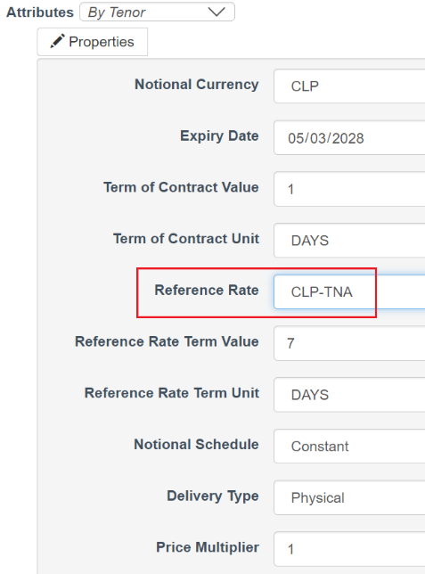  - Reference Rate that has one ISDA FRO Definition (e.g. 2006 or 2021).  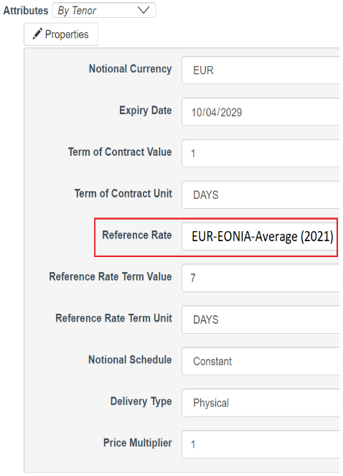  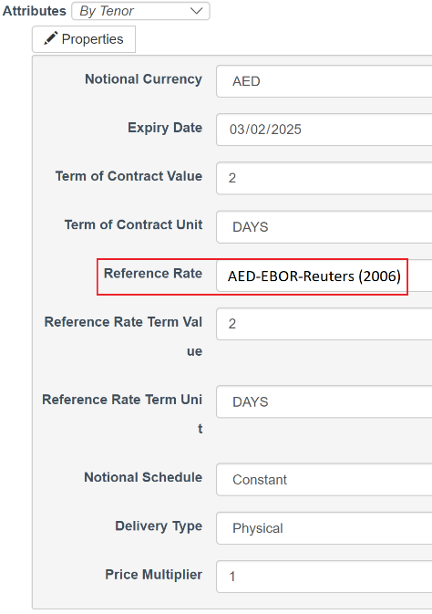  - Reference Rate that has two (2) ISDA FRO Definitions (2006, 2021).  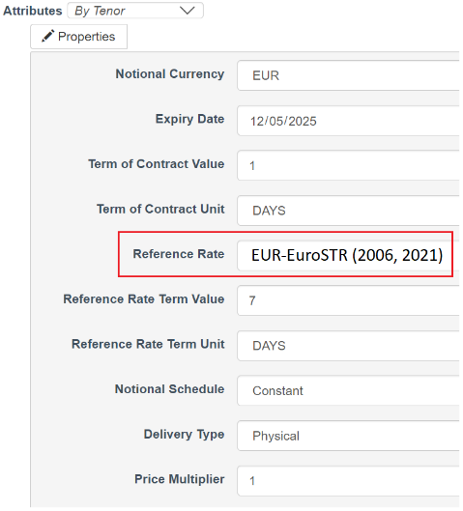  - Once GUI users send their requests, the DSB will return the output message without the suffix of the ISDA FRO Definitions as shown on illustration below. This logic applies to all three (3) layouts enumerated above:  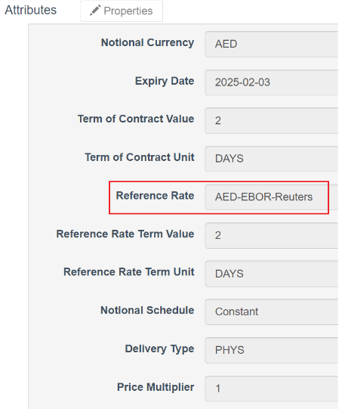  - Since this enhancement will only impact GUI users, API users will continue to use the unadjusted FRO name as shown on the illustration below:  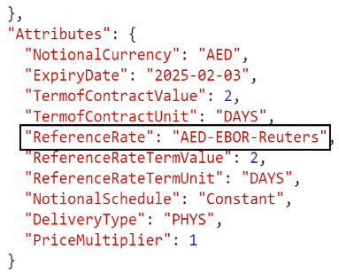
Validation | Not Required.
Derivation | The current OTC ISIN derivation that is made available in the DSB Production environment will apply.
Impacted Products | Update the enum_title of the FROs (please refer to Appendix 1) to the following enumerated lists:  Enumerated value to be updated to Reference Rate:  - Rates.Swap.Cross_Currency_Fixed_Float  - Rates.Swap.Cross_Currency_Fixed_Float_NDS  - Rates.Swap.Cross_Currency_Zero_Coupon  - Rates.Swap.Fixed_Float  - Rates.Swap.Fixed_Float_OIS  - Rates.Swap.Fixed_Float_Zero_Coupon  - Rates.Option.Non_Standard  - Rates.Forward.FRA_Index  Enumerated value to be updated to Underlying Instrument Index:  - Rates.Option.CapFloor  Enumerated value to be updated to Reference Rate and Other Leg Reference Rate:  - Rates.Swap.Basis  - Rates.Swap.Basis_OIS  - Rates.Swap.Cross_Currency_Basis  - Rates.Swap.Non_Standard  - Other.Swap.Non_Standard  - Other.Option.Non_Standard  - Other.Other.Non_Standard  Enumerated value to be updated to Other Leg Reference Rate where the component is “Inflation vs Floating”:  - Rates.Swap.Inflation_Basis  Note:  - Impacts Normalised and Non-Normalised templates.
User Impact? | Yes | Users will need to download the updated templates in order to access all updated FROs.
 | Versions | The version number of all in-scope Record templates will not be impacted.
Use Cases | For each of the in-scope templates:  Valid Request:  - For GUI users selecting each of the different types.  - For API users [REST & FIX] selecting each of the different types and ensure they are not impacted with this enhancement.
Backward Compatibility | - No issues on the existing OTC ISIN as end users can still search previously created OTC ISINs in the GUI and in API.  - No impact to API users as they will continuously use the unadjusted FRO enumerated values.
Change Management | The DSB ensures the suffix added to the Reference Rate dropdown in the GUI is kept in line with FpML Coding Scheme xml through performing the following procedures on an annual basis:  - Retrieve the metadata file from the latest version of FpML Coding Scheme xml (Location URL: https://www.fpml.org/coding-scheme/floating-rate-index-3-3.xml) and copy the same in excel format.  - Using the excel functions (LEFT, MID, RIGHT, FIND, LEN), get the exact value of the FRO names and their corresponding ISDA FRO Definitions (i.e., 2000, 2006, 2021).  - Get the exact value of the FRO name by extracting the value contained in the following section of the metadata file highlighted below:  e.g. <SimpleValue>AED-EBOR-Reuters</SimpleValue>  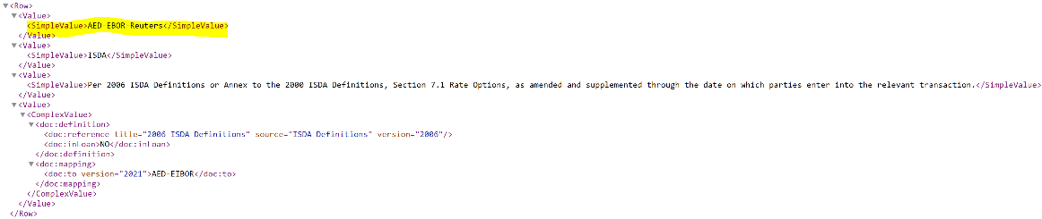  - Get the exact value of the ISDA FRO Definition by extracting the value contained in the following section of the metadata file highlighted below:  e.g: <doc:reference title="2006 ISDA Definitions" source="ISDA Definitions" version="2006"/>  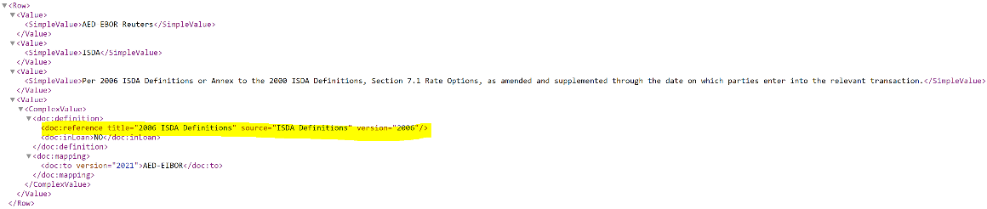  - Copy the extracted values from item b on a separate sheet and save in respective DSB Jira Documentation folder. Sample of the data file can be found here.  - For getting the exact values of FRO names and their corresponding ISDA FRO Definitions, we are excluding the following details in the metadata file as shown in the sample illustration below:  - Simple Value of ISDA FRO Definition: <SimpleValue>Per 2006 ISDA Definitions or Annex to the 2000 ISDA Definitions, Section 7.1 Rate Options, as amended and supplemented through the date on which parties enter into the relevant transaction.</SimpleValue>  - Start Date: <doc:startDate>2000-07-17</doc:startDate>  - First Defined In: <doc:firstDefinedIn>ISDA2000</doc:firstDefinedIn>  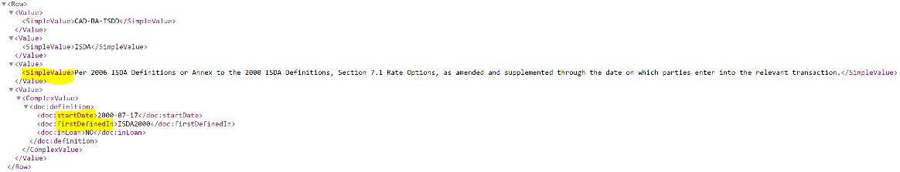  - It is expected that an FRO may have zero, one, two or more entries of ISDA FRO Definition (i.e., 2000, 2006, 2021).
Documentation | The following DSB documents are to be updated:  DSB UAT Annex 7 Indices :  https://www.anna-dsb.com/download/dsb-uat-product-definitions-annex-7-indices/  DSB PROD Annex 7 Indices :  https://www.anna-dsb.com/download/dsb-prod-product-definitions-annex-7-indices/  DSB FAQ :  https://www.anna-dsb.com/faq/
Reference | https://www.fpml.org/coding-scheme/floating-rate-index-3-3.xml(FpML Scheme Definition: floatingRateIndexScheme)

Appendix 1

After adding the ISDA FRO Definition suffix to the Reference Rate Dropdown for GUI users that is taken from https://www.fpml.org/coding-scheme/floating-rate-index-3-3.xml (FpML Scheme Definition: floatingRateIndexScheme), the full list of Reference Rates and enum_title that are to Go-LIVE in the DSB Production should look exactly the same as per table below:

- 2006 ISDA Definitions: 395 FROs
- 2021 ISDA Definitions: 106 FROs
- 2006 and 2021 ISDA Definitions: 80 FROs
- No ISDA Definition provided: 35 FROs

Note: Rates-CPI are not impacted and remains unchanged.

Reference Rate / Underlying Instrument Index | Enum_Title
AED-EBOR-Reuters | AED-EBOR-Reuters (2006)
AED-EIBOR | AED-EIBOR (2021)
AUD-AONIA | AUD-AONIA (2006, 2021)
AUD-AONIA-OIS Compound | AUD-AONIA-OIS Compound (2021)
AUD-AONIA-OIS-COMPOUND | AUD-AONIA-OIS-COMPOUND (2006)
AUD-AONIA-OIS-COMPOUND-SwapMarker | AUD-AONIA-OIS-COMPOUND-SwapMarker (2006)
AUD-BBR-AUBBSW | AUD-BBR-AUBBSW (2006)
AUD-BBR-BBSW | AUD-BBR-BBSW (2006)
AUD-BBR-BBSW-Bloomberg | AUD-BBR-BBSW-Bloomberg (2006)
AUD-BBR-BBSY (BID) | AUD-BBR-BBSY (BID) (2006)
AUD-BBR-ISDC | AUD-BBR-ISDC
AUD-BBSW | AUD-BBSW (2021)
AUD-BBSW Quarterly Swap Rate ICAP | AUD-BBSW Quarterly Swap Rate ICAP (2021)
AUD-BBSW Semi Annual Swap Rate ICAP | AUD-BBSW Semi Annual Swap Rate ICAP (2021)
AUD-BBSY Bid | AUD-BBSY Bid (2021)
AUD-LIBOR-BBA | AUD-LIBOR-BBA (2006)
AUD-LIBOR-BBA-Bloomberg | AUD-LIBOR-BBA-Bloomberg (2006)
AUD-LIBOR-Reference Banks | AUD-LIBOR-Reference Banks (2006)
AUD-Quarterly Swap Rate-ICAP | AUD-Quarterly Swap Rate-ICAP (2006)
AUD-Quarterly Swap Rate-ICAP-Reference Banks | AUD-Quarterly Swap Rate-ICAP-Reference Banks (2006)
AUD-Semi-Annual Swap Rate-11:00-BGCANTOR | AUD-Semi-Annual Swap Rate-11:00-BGCANTOR (2006)
AUD-Semi-Annual Swap Rate-BGCANTOR-Reference Banks | AUD-Semi-Annual Swap Rate-BGCANTOR-Reference Banks (2006)
AUD-Semi-annual Swap Rate-ICAP | AUD-Semi-annual Swap Rate-ICAP (2006)
AUD-Semi-Annual Swap Rate-ICAP-Reference Banks | AUD-Semi-Annual Swap Rate-ICAP-Reference Banks (2006)
AUD-Swap Rate-Reuters | AUD-Swap Rate-Reuters (2006)
BRL-CDI | BRL-CDI (2021)
CAD-BA-CDOR | CAD-BA-CDOR (2006)
CAD-BA-CDOR-Bloomberg | CAD-BA-CDOR-Bloomberg (2006)
CAD-BA-ISDD | CAD-BA-ISDD
CAD-BA-Reference Banks | CAD-BA-Reference Banks (2006)
CAD-BA-Reuters | CAD-BA-Reuters (2006)
CAD-BA-Telerate | CAD-BA-Telerate
CAD-CDOR | CAD-CDOR (2021)
CAD-CORRA | CAD-CORRA (2006, 2021)
CAD-CORRA-OIS Compound | CAD-CORRA-OIS Compound (2021)
CAD-CORRA-OIS-COMPOUND | CAD-CORRA-OIS-COMPOUND (2006)
CAD-ISDA-Swap Rate | CAD-ISDA-Swap Rate (2006)
CAD-LIBOR-BBA | CAD-LIBOR-BBA (2006)
CAD-LIBOR-BBA-Bloomberg | CAD-LIBOR-BBA-Bloomberg (2006)
CAD-LIBOR-BBA-SwapMarker | CAD-LIBOR-BBA-SwapMarker (2006)
CAD-LIBOR-Reference Banks | CAD-LIBOR-Reference Banks (2006)
CAD-REPO-CORRA | CAD-REPO-CORRA (2006)
CAD-TBILL-ISDD | CAD-TBILL-ISDD
CAD-TBILL-Reference Banks | CAD-TBILL-Reference Banks (2006)
CAD-TBILL-Reuters | CAD-TBILL-Reuters (2006)
CAD-TBILL-Telerate | CAD-TBILL-Telerate
CHF USD-Basis Swaps-11:00-ICAP | CHF USD-Basis Swaps-11:00-ICAP (2006)
CHF-3M LIBOR SWAP-CME vs LCH-ICAP | CHF-3M LIBOR SWAP-CME vs LCH-ICAP (2006)
CHF-3M LIBOR SWAP-CME vs LCH-ICAP-Bloomberg | CHF-3M LIBOR SWAP-CME vs LCH-ICAP-Bloomberg (2006)
CHF-3M LIBOR SWAP-EUREX vs LCH-ICAP | CHF-3M LIBOR SWAP-EUREX vs LCH-ICAP (2006)
CHF-3M LIBOR SWAP-EUREX vs LCH-ICAP-Bloomberg | CHF-3M LIBOR SWAP-EUREX vs LCH-ICAP-Bloomberg (2006)
CHF-6M LIBOR SWAP-CME vs LCH-ICAP | CHF-6M LIBOR SWAP-CME vs LCH-ICAP (2006)
CHF-6M LIBOR SWAP-EUREX vs LCH-ICAP | CHF-6M LIBOR SWAP-EUREX vs LCH-ICAP (2006)
CHF-6M LIBOR SWAP-EUREX vs LCH-ICAP-Bloomberg | CHF-6M LIBOR SWAP-EUREX vs LCH-ICAP-Bloomberg (2006)
CHF-6M LIBORSWAP-CME vs LCH-ICAP-Bloomberg | CHF-6M LIBORSWAP-CME vs LCH-ICAP-Bloomberg (2006)
CHF-Annual Swap Rate | CHF-Annual Swap Rate (2006)
CHF-Annual Swap Rate-11:00-ICAP | CHF-Annual Swap Rate-11:00-ICAP (2006)
CHF-Annual Swap Rate-Reference Banks | CHF-Annual Swap Rate-Reference Banks (2006)
CHF-Basis Swap-3m vs 6m-LIBOR-11:00-ICAP | CHF-Basis Swap-3m vs 6m-LIBOR-11:00-ICAP (2006)
CHF-ISDAFIX-Swap Rate | CHF-ISDAFIX-Swap Rate (2006)
CHF-LIBOR | CHF-LIBOR (2021)
CHF-LIBOR-BBA | CHF-LIBOR-BBA (2006)
CHF-LIBOR-BBA-Bloomberg | CHF-LIBOR-BBA-Bloomberg (2006)
CHF-LIBOR-ISDA | CHF-LIBOR-ISDA
CHF-LIBOR-Reference Banks | CHF-LIBOR-Reference Banks (2006)
CHF-OIS-11:00-ICAP | CHF-OIS-11:00-ICAP (2006)
CHF-SARON | CHF-SARON (2006, 2021)
CHF-SARON-OIS Compound | CHF-SARON-OIS Compound (2021)
CHF-SARON-OIS-COMPOUND | CHF-SARON-OIS-COMPOUND (2006)
CHF-TOIS-OIS-COMPOUND | CHF-TOIS-OIS-COMPOUND (2006)
CL-CLICP-Bloomberg | CL-CLICP-Bloomberg (2006)
CLP-ICP | CLP-ICP (2021)
CLP-TNA | CLP-TNA
CNH-HIBOR | CNH-HIBOR (2021)
CNH-HIBOR-Reference Banks | CNH-HIBOR-Reference Banks (2006)
CNH-HIBOR-TMA | CNH-HIBOR-TMA (2006)
CNY 7-Repo Compounding Date | CNY 7-Repo Compounding Date (2006)
CNY-CNREPOFIX=CFXS-Reuters | CNY-CNREPOFIX=CFXS-Reuters (2006)
CNY-Deposit Rate | CNY-Deposit Rate (2021)
CNY-Fixing Repo Rate | CNY-Fixing Repo Rate (2021)
CNY-LPR | CNY-LPR (2021)
CNY-PBOCB-Reuters | CNY-PBOCB-Reuters (2006)
CNY-Quarterly 7 day Repo Non Deliverable Swap Rate-TRADITION | CNY-Quarterly 7 day Repo Non Deliverable Swap Rate-TRADITION (2006)
CNY-Quarterly 7 day Repo Non Deliverable Swap Rate-TRADITION-Reference Banks | CNY-Quarterly 7 day Repo Non Deliverable Swap Rate-TRADITION-Reference Banks (2006)
CNY-Quarterly 7D Repo NDS Rate Tradition | CNY-Quarterly 7D Repo NDS Rate Tradition (2021)
CNY-Semi-Annual Swap Rate-11:00-BGCANTOR | CNY-Semi-Annual Swap Rate-11:00-BGCANTOR (2006)
CNY-Semi-Annual Swap Rate-Reference Banks | CNY-Semi-Annual Swap Rate-Reference Banks (2006)
CNY-SHIBOR | CNY-SHIBOR (2021)
CNY-SHIBOR-OIS Compound | CNY-SHIBOR-OIS Compound (2021)
CNY-Shibor-OIS-Compounding | CNY-Shibor-OIS-Compounding (2006)
CNY-SHIBOR-Reuters | CNY-SHIBOR-Reuters (2006)
COP-IBR-OIS Compound | COP-IBR-OIS Compound (2021)
COP-IBR-OIS-COMPOUND | COP-IBR-OIS-COMPOUND (2006)
CZK-Annual Swap Rate-11:00-BGCANTOR | CZK-Annual Swap Rate-11:00-BGCANTOR (2006)
CZK-Annual Swap Rate-Reference Banks | CZK-Annual Swap Rate-Reference Banks (2006)
CZK-CZEONIA | CZK-CZEONIA (2021)
CZK-CZEONIA-OIS Compound | CZK-CZEONIA-OIS Compound (2021)
CZK-PRIBOR | CZK-PRIBOR (2021)
CZK-PRIBOR-PRBO | CZK-PRIBOR-PRBO (2006)
CZK-PRIBOR-Reference Banks | CZK-PRIBOR-Reference Banks (2006)
DKK-CIBOR | DKK-CIBOR (2021)
DKK-CIBOR2 | DKK-CIBOR2 (2021)
DKK-CIBOR2-Bloomberg | DKK-CIBOR2-Bloomberg (2006)
DKK-CIBOR2-DKNA13 | DKK-CIBOR2-DKNA13 (2006)
DKK-CIBOR-DKNA13 | DKK-CIBOR-DKNA13 (2006)
DKK-CIBOR-DKNA13-Bloomberg | DKK-CIBOR-DKNA13-Bloomberg (2006)
DKK-CIBOR-Reference Banks | DKK-CIBOR-Reference Banks (2006)
DKK-CITA | DKK-CITA (2021)
DKK-CITA-DKNA14-COMPOUND | DKK-CITA-DKNA14-COMPOUND (2006)
DKK-DKKOIS-OIS-COMPOUND | DKK-DKKOIS-OIS-COMPOUND (2006)
DKK-Tom Next-OIS Compound | DKK-Tom Next-OIS Compound (2021)
EUR Basis Swap-EONIA vs 3m EUR+IBOR Swap Rates-A/360-10:00-ICAP | EUR Basis Swap-EONIA vs 3m EUR+IBOR Swap Rates-A/360-10:00-ICAP (2006)
EUR EURIBOR-Annual Bond Swap vs 1m-11:00-ICAP | EUR EURIBOR-Annual Bond Swap vs 1m-11:00-ICAP (2006)
EUR EURIBOR-Basis Swap-1m vs 3m-Euribor-11:00-ICAP | EUR EURIBOR-Basis Swap-1m vs 3m-Euribor-11:00-ICAP (2006)
EUR EURIBOR-Basis Swap-3m vs 6m-11:00-ICAP | EUR EURIBOR-Basis Swap-3m vs 6m-11:00-ICAP (2006)
EUR USD-Basis Swaps-11:00-ICAP | EUR USD-Basis Swaps-11:00-ICAP (2006)
EUR-3M EURIBOR SWAP-CME vs LCH-ICAP | EUR-3M EURIBOR SWAP-CME vs LCH-ICAP (2006)
EUR-3M EURIBOR SWAP-CME vs LCH-ICAP-Bloomberg | EUR-3M EURIBOR SWAP-CME vs LCH-ICAP-Bloomberg (2006)
EUR-3M EURIBOR SWAP-EUREX vs LCH-ICAP | EUR-3M EURIBOR SWAP-EUREX vs LCH-ICAP (2006)
EUR-3M EURIBOR SWAP-EUREX vs LCH-ICAP-Bloomberg | EUR-3M EURIBOR SWAP-EUREX vs LCH-ICAP-Bloomberg (2006)
EUR-6M EURIBOR SWAP-CME vs LCH-ICAP | EUR-6M EURIBOR SWAP-CME vs LCH-ICAP (2006)
EUR-6M EURIBOR SWAP-CME vs LCH-ICAP-Bloomberg | EUR-6M EURIBOR SWAP-CME vs LCH-ICAP-Bloomberg (2006)
EUR-6M EURIBOR SWAP-EUREX vs LCH-ICAP | EUR-6M EURIBOR SWAP-EUREX vs LCH-ICAP (2006)
EUR-6M EURIBOR SWAP-EUREX vs LCH-ICAP-Bloomberg | EUR-6M EURIBOR SWAP-EUREX vs LCH-ICAP-Bloomberg (2006)
EUR-Annual Swap Rate-10:00 | EUR-Annual Swap Rate-10:00 (2006)
EUR-Annual Swap Rate-10:00-BGCANTOR | EUR-Annual Swap Rate-10:00-BGCANTOR (2006)
EUR-Annual Swap Rate-10:00-Bloomberg | EUR-Annual Swap Rate-10:00-Bloomberg (2006)
EUR-Annual Swap Rate-10:00-ICAP | EUR-Annual Swap Rate-10:00-ICAP (2006)
EUR-Annual Swap Rate-10:00-SwapMarker | EUR-Annual Swap Rate-10:00-SwapMarker (2006)
EUR-Annual Swap Rate-10:00-TRADITION | EUR-Annual Swap Rate-10:00-TRADITION (2006)
EUR-Annual Swap Rate-11:00 | EUR-Annual Swap Rate-11:00 (2006)
EUR-Annual Swap Rate-11:00-Bloomberg | EUR-Annual Swap Rate-11:00-Bloomberg (2006)
EUR-Annual Swap Rate-11:00-ICAP | EUR-Annual Swap Rate-11:00-ICAP (2006)
EUR-Annual Swap Rate-11:00-SwapMarker | EUR-Annual Swap Rate-11:00-SwapMarker (2006)
EUR-Annual Swap Rate-3 Month | EUR-Annual Swap Rate-3 Month (2006)
EUR-Annual Swap Rate-3 Month-SwapMarker | EUR-Annual Swap Rate-3 Month-SwapMarker (2006)
EUR-Annual Swap Rate-4:15-TRADITION | EUR-Annual Swap Rate-4:15-TRADITION (2006)
EUR-Annual Swap Rate-Reference Banks | EUR-Annual Swap Rate-Reference Banks (2006)
EUR-CNO TEC10 | EUR-CNO TEC10 (2021)
EUR-EONIA | EUR-EONIA (2021)
EUR-EONIA-AVERAGE | EUR-EONIA-AVERAGE (2006)
EUR-EONIA-Average | EUR-EONIA-Average (2021)
EUR-EONIA-OIS Compound | EUR-EONIA-OIS Compound (2021)
EUR-EONIA-OIS-10:00-BGCANTOR | EUR-EONIA-OIS-10:00-BGCANTOR (2006)
EUR-EONIA-OIS-10:00-ICAP | EUR-EONIA-OIS-10:00-ICAP (2006)
EUR-EONIA-OIS-10:00-TRADITION | EUR-EONIA-OIS-10:00-TRADITION (2006)
EUR-EONIA-OIS-11:00-ICAP | EUR-EONIA-OIS-11:00-ICAP (2006)
EUR-EONIA-OIS-4:15-TRADITION | EUR-EONIA-OIS-4:15-TRADITION (2006)
EUR-EONIA-OIS-COMPOUND | EUR-EONIA-OIS-COMPOUND (2006)
EUR-EONIA-OIS-COMPOUND-Bloomberg | EUR-EONIA-OIS-COMPOUND-Bloomberg (2006)
EUR-EONIA-Swap-Index | EUR-EONIA-Swap-Index (2006)
EUR-EURIBOR | EUR-EURIBOR (2021)
EUR-EURIBOR ICE Swap Rate-11:00 | EUR-EURIBOR ICE Swap Rate-11:00 (2021)
EUR-EURIBOR ICE Swap Rate-12:00 | EUR-EURIBOR ICE Swap Rate-12:00 (2021)
EUR-EURIBOR-Act/365 | EUR-EURIBOR-Act/365 (2006)
EUR-EURIBOR-Act/365-Bloomberg | EUR-EURIBOR-Act/365-Bloomberg (2006)
EUR-EURIBOR-Reference Banks | EUR-EURIBOR-Reference Banks (2006)
EUR-EURIBOR-Reuters | EUR-EURIBOR-Reuters (2006)
EUR-EURIBOR-Telerate | EUR-EURIBOR-Telerate
EUR-EURONIA-OIS Compound | EUR-EURONIA-OIS Compound (2021)
EUR-EURONIA-OIS-COMPOUND | EUR-EURONIA-OIS-COMPOUND (2006)
EUR-EuroSTR | EUR-EuroSTR (2006, 2021)
EUR-EuroSTR Average 12M | EUR-EuroSTR Average 12M (2006, 2021)
EUR-EuroSTR Average 1M | EUR-EuroSTR Average 1M (2006, 2021)
EUR-EuroSTR Average 1W | EUR-EuroSTR Average 1W (2006, 2021)
EUR-EuroSTR Average 3M | EUR-EuroSTR Average 3M (2006, 2021)
EUR-EuroSTR Average 6M | EUR-EuroSTR Average 6M (2006, 2021)
EUR-EuroSTR Compounded Index | EUR-EuroSTR Compounded Index (2006, 2021)
EUR-EuroSTR-COMPOUND | EUR-EuroSTR-COMPOUND (2006)
EUR-EuroSTR ICE Compounded Index | EUR-EuroSTR ICE Compounded Index (2006, 2021)
EUR-EuroSTR ICE Compounded Index 0 Floor | EUR-EuroSTR ICE Compounded Index 0 Floor (2006, 2021)
EUR-EuroSTR ICE Compounded Index 0 Floor 2D Lag | EUR-EuroSTR ICE Compounded Index 0 Floor 2D Lag (2006, 2021)
EUR-EuroSTR ICE Compounded Index 0 Floor 5D Lag | EUR-EuroSTR ICE Compounded Index 0 Floor 5D Lag (2006, 2021)
EUR-EuroSTR ICE Compounded Index 2D Lag | EUR-EuroSTR ICE Compounded Index 2D Lag (2006, 2021)
EUR-EuroSTR ICE Compounded Index 5D Lag | EUR-EuroSTR ICE Compounded Index 5D Lag (2006, 2021)
EUR-EuroSTR-OIS Compound | EUR-EuroSTR-OIS Compound (2021)
EUR-ISDA-EURIBOR Swap Rate-11:00 | EUR-ISDA-EURIBOR Swap Rate-11:00 (2006)
EUR-ISDA-EURIBOR Swap Rate-12:00 | EUR-ISDA-EURIBOR Swap Rate-12:00 (2006)
EUR-ISDA-LIBOR Swap Rate-10:00 | EUR-ISDA-LIBOR Swap Rate-10:00 (2006)
EUR-ISDA-LIBOR Swap Rate-11:00 | EUR-ISDA-LIBOR Swap Rate-11:00 (2006)
EUR-LIBOR | EUR-LIBOR (2021)
EUR-LIBOR-BBA | EUR-LIBOR-BBA (2006)
EUR-LIBOR-BBA-Bloomberg | EUR-LIBOR-BBA-Bloomberg (2006)
EUR-LIBOR-Reference Banks | EUR-LIBOR-Reference Banks (2006)
EUR-TAM-CDC | EUR-TAM-CDC
EUR-TEC10-CNO | EUR-TEC10-CNO (2006)
EUR-TEC10-CNO-SwapMarker | EUR-TEC10-CNO-SwapMarker (2006)
EUR-TEC10-Reference Banks | EUR-TEC10-Reference Banks (2006)
EUR-TEC5-CNO | EUR-TEC5-CNO (2006)
EUR-TEC5-CNO-SwapMarker | EUR-TEC5-CNO-SwapMarker (2006)
EUR-TEC5-Reference Banks | EUR-TEC5-Reference Banks (2006)
EUR-TMM-CDC-COMPOUND | EUR-TMM-CDC-COMPOUND
GBP USD-Basis Swaps-11:00-ICAP | GBP USD-Basis Swaps-11:00-ICAP (2006)
GBP-6M LIBOR SWAP-CME vs LCH-ICAP | GBP-6M LIBOR SWAP-CME vs LCH-ICAP (2006)
GBP-6M LIBOR SWAP-CME vs LCH-ICAP-Bloomberg | GBP-6M LIBOR SWAP-CME vs LCH-ICAP-Bloomberg (2006)
GBP-6M LIBOR SWAP-EUREX vs LCH-ICAP | GBP-6M LIBOR SWAP-EUREX vs LCH-ICAP (2006)
GBP-6M LIBOR SWAP-EUREX vs LCH-ICAP-Bloomberg | GBP-6M LIBOR SWAP-EUREX vs LCH-ICAP-Bloomberg (2006)
GBP-ISDA-Swap Rate | GBP-ISDA-Swap Rate (2006)
GBP-LIBOR | GBP-LIBOR (2021)
GBP-LIBOR ICE Swap Rate | GBP-LIBOR ICE Swap Rate (2021)
GBP-LIBOR-BBA | GBP-LIBOR-BBA (2006)
GBP-LIBOR-BBA-Bloomberg | GBP-LIBOR-BBA-Bloomberg (2006)
GBP-LIBOR-ISDA | GBP-LIBOR-ISDA
GBP-LIBOR-Reference Banks | GBP-LIBOR-Reference Banks (2006)
GBP-RONIA | GBP-RONIA (2021)
GBP-RONIA-OIS Compound | GBP-RONIA-OIS Compound (2021)
GBP-Semi Annual Swap Rate-11:00-TRADITION | GBP-Semi Annual Swap Rate-11:00-TRADITION (2006)
GBP-Semi Annual Swap Rate-4:15-TRADITION | GBP-Semi Annual Swap Rate-4:15-TRADITION (2006)
GBP-Semi-Annual Swap Rate | GBP-Semi-Annual Swap Rate (2006)
GBP-Semi-Annual Swap Rate-11:00-ICAP | GBP-Semi-Annual Swap Rate-11:00-ICAP (2006)
GBP-Semi-Annual Swap Rate-Reference Banks | GBP-Semi-Annual Swap Rate-Reference Banks (2006)
GBP-Semi-Annual Swap Rate-SwapMarker26 | GBP-Semi-Annual Swap Rate-SwapMarker26 (2006)
GBP-SONIA | GBP-SONIA (2006, 2021)
GBP-SONIA Compounded Index | GBP-SONIA Compounded Index (2006, 2021)
GBP-SONIA ICE Compounded Index | GBP-SONIA ICE Compounded Index (2006, 2021)
GBP-SONIA ICE Compounded Index 0 Floor | GBP-SONIA ICE Compounded Index 0 Floor (2006, 2021)
GBP-SONIA ICE Compounded Index 0 Floor 2D Lag | GBP-SONIA ICE Compounded Index 0 Floor 2D Lag (2006, 2021)
GBP-SONIA ICE Compounded Index 0 Floor 5D Lag | GBP-SONIA ICE Compounded Index 0 Floor 5D Lag (2006, 2021)
GBP-SONIA ICE Compounded Index 2D Lag | GBP-SONIA ICE Compounded Index 2D Lag (2006, 2021)
GBP-SONIA ICE Compounded Index 5D Lag | GBP-SONIA ICE Compounded Index 5D Lag (2006, 2021)
GBP-SONIA ICE Swap Rate | GBP-SONIA ICE Swap Rate (2021)
GBP-SONIA ICE Term | GBP-SONIA ICE Term (2006, 2021)
GBP-SONIA Refinitiv Term | GBP-SONIA Refinitiv Term (2006, 2021)
GBP-SONIA Swap Rate | GBP-SONIA Swap Rate (2006)
GBP-SONIA-COMPOUND | GBP-SONIA-COMPOUND (2006)
GBP-SONIA-OIS Compound | GBP-SONIA-OIS Compound (2021)
GBP-SONIA-OIS-11:00-ICAP | GBP-SONIA-OIS-11:00-ICAP (2006)
GBP-SONIA-OIS-11:00-TRADITION | GBP-SONIA-OIS-11:00-TRADITION (2006)
GBP-SONIA-OIS-4:15-TRADITION | GBP-SONIA-OIS-4:15-TRADITION (2006)
GBP-UK Base Rate | GBP-UK Base Rate (2021)
GBP-WMBA-RONIA-COMPOUND | GBP-WMBA-RONIA-COMPOUND (2006)
GBP-WMBA-SONIA-COMPOUND | GBP-WMBA-SONIA-COMPOUND (2006)
GRD-ATHIBOR-ATHIBOR | GRD-ATHIBOR-ATHIBOR
GRD-ATHIBOR-Reference Banks | GRD-ATHIBOR-Reference Banks
GRD-ATHIBOR-Telerate | GRD-ATHIBOR-Telerate
GRD-ATHIMID-Reference Banks | GRD-ATHIMID-Reference Banks
GRD-ATHIMID-Reuters | GRD-ATHIMID-Reuters
HKD-HIBOR | HKD-HIBOR (2021)
HKD-HIBOR-HIBOR= | HKD-HIBOR-HIBOR= (2006)
HKD-HIBOR-HIBOR-Bloomberg | HKD-HIBOR-HIBOR-Bloomberg (2006)
HKD-HIBOR-HKAB | HKD-HIBOR-HKAB (2006)
HKD-HIBOR-HKAB-Bloomberg | HKD-HIBOR-HKAB-Bloomberg (2006)
HKD-HIBOR-ISDC | HKD-HIBOR-ISDC
HKD-HIBOR-Reference Banks | HKD-HIBOR-Reference Banks (2006)
HKD-HONIA | HKD-HONIA (2006, 2021)
HKD-HONIA-OIS Compound | HKD-HONIA-OIS Compound (2021)
HKD-HONIX-OIS-COMPOUND | HKD-HONIX-OIS-COMPOUND (2006)
HKD-ISDA-Swap Rate-11:00 | HKD-ISDA-Swap Rate-11:00 (2006)
HKD-ISDA-Swap Rate-4:00 | HKD-ISDA-Swap Rate-4:00 (2006)
HKD-Quarterly-Annual Swap Rate-11:00-BGCANTOR | HKD-Quarterly-Annual Swap Rate-11:00-BGCANTOR (2006)
HKD-Quarterly-Annual Swap Rate-11:00-TRADITION | HKD-Quarterly-Annual Swap Rate-11:00-TRADITION (2006)
HKD-Quarterly-Annual Swap Rate-4:00-BGCANTOR | HKD-Quarterly-Annual Swap Rate-4:00-BGCANTOR (2006)
HKD-Quarterly-Annual Swap Rate-Reference Banks | HKD-Quarterly-Annual Swap Rate-Reference Banks (2006)
HKD-Quarterly-Quarterly Swap Rate-11:00-ICAP | HKD-Quarterly-Quarterly Swap Rate-11:00-ICAP (2006)
HKD-Quarterly-Quarterly Swap Rate-4:00-ICAP | HKD-Quarterly-Quarterly Swap Rate-4:00-ICAP (2006)
HKD-Quarterly-Quarterly Swap Rate-Reference Banks | HKD-Quarterly-Quarterly Swap Rate-Reference Banks (2006)
HUF-BUBOR | HUF-BUBOR (2021)
HUF-BUBOR-Reference Banks | HUF-BUBOR-Reference Banks (2006)
HUF-BUBOR-Reuters | HUF-BUBOR-Reuters (2006)
HUF-HUFONIA | HUF-HUFONIA (2021)
IDR-IDMA-Bloomberg | IDR-IDMA-Bloomberg (2006)
IDR-IDRFIX | IDR-IDRFIX (2006)
IDR-JIBOR | IDR-JIBOR (2021)
IDR-JIBOR-Reuters | IDR-JIBOR-Reuters (2006)
IDR-SBI-Reuters | IDR-SBI-Reuters (2006)
IDR-Semi Annual Swap Rate-Non-deliverable-16:00-Tullett Prebon | IDR-Semi Annual Swap Rate-Non-deliverable-16:00-Tullett Prebon (2006)
IDR-Semi-Annual Swap Rate-11:00-BGCANTOR | IDR-Semi-Annual Swap Rate-11:00-BGCANTOR (2006)
IDR-Semi-Annual Swap Rate-Reference Banks | IDR-Semi-Annual Swap Rate-Reference Banks (2006)
IDR-SOR-Reference Banks | IDR-SOR-Reference Banks (2006)
IDR-SOR-Reuters | IDR-SOR-Reuters (2006)
IDR-SOR-Telerate | IDR-SOR-Telerate
ILS-TELBOR | ILS-TELBOR (2021)
ILS-TELBOR01-Reuters | ILS-TELBOR01-Reuters (2006)
ILS-TELBOR-Reference Banks | ILS-TELBOR-Reference Banks (2006)
INR-BMK | INR-BMK (2006)
INR-CMT | INR-CMT (2006)
INR-FBIL-MIBOR-OIS-COMPOUND | INR-FBIL-MIBOR-OIS-COMPOUND (2006)
INR-INBMK-REUTERS | INR-INBMK-REUTERS (2006)
INR-MIBOR OIS | INR-MIBOR OIS (2021)
INR-MIBOR-OIS Compound | INR-MIBOR-OIS Compound (2021)
INR-MIBOR-OIS-COMPOUND | INR-MIBOR-OIS-COMPOUND (2006)
INR-MIFOR | INR-MIFOR (2006, 2021)
INR-MIOIS | INR-MIOIS (2006)
INR-MITOR-OIS-COMPOUND | INR-MITOR-OIS-COMPOUND (2006)
INR-Modified MIFOR | INR-Modified MIFOR (2006, 2021)
INR-Reference Banks | INR-Reference Banks (2006)
INR-Semi Annual Swap Rate-Non-deliverable-16:00-Tullett Prebon | INR-Semi Annual Swap Rate-Non-deliverable-16:00-Tullett Prebon (2006)
INR-Semi-Annual Swap Rate-11:30-BGCANTOR | INR-Semi-Annual Swap Rate-11:30-BGCANTOR (2006)
INR-Semi-Annual Swap Rate-Reference Banks | INR-Semi-Annual Swap Rate-Reference Banks (2006)
ISK-REIBOR | ISK-REIBOR (2021)
ISK-REIBOR-Reference Banks | ISK-REIBOR-Reference Banks (2006)
ISK-REIBOR-Reuters | ISK-REIBOR-Reuters (2006)
JPY USD-Basis Swaps-11:00-ICAP | JPY USD-Basis Swaps-11:00-ICAP (2006)
JPY-Annual Swap Rate-11:00-TRADITION | JPY-Annual Swap Rate-11:00-TRADITION (2006)
JPY-Annual Swap Rate-3:00-TRADITION | JPY-Annual Swap Rate-3:00-TRADITION (2006)
JPY-BBSF-Bloomberg-10:00 | JPY-BBSF-Bloomberg-10:00 (2006)
JPY-BBSF-Bloomberg-15:00 | JPY-BBSF-Bloomberg-15:00 (2006)
JPY-Euroyen TIBOR | JPY-Euroyen TIBOR (2021)
JPY-ISDA-Swap Rate-10:00 | JPY-ISDA-Swap Rate-10:00 (2006)
JPY-ISDA-Swap Rate-15:00 | JPY-ISDA-Swap Rate-15:00 (2006)
JPY-LIBOR | JPY-LIBOR (2021)
JPY-LIBOR TSR-10:00 | JPY-LIBOR TSR-10:00 (2021)
JPY-LIBOR TSR-15:00 | JPY-LIBOR TSR-15:00 (2021)
JPY-LIBOR-BBA | JPY-LIBOR-BBA (2006)
JPY-LIBOR-BBA-Bloomberg | JPY-LIBOR-BBA-Bloomberg (2006)
JPY-LIBOR-FRASETT | JPY-LIBOR-FRASETT (2006)
JPY-LIBOR-ISDA | JPY-LIBOR-ISDA
JPY-LIBOR-Reference Banks | JPY-LIBOR-Reference Banks (2006)
JPY-LTPR MHBK | JPY-LTPR MHBK (2021)
JPY-LTPR-MHCB | JPY-LTPR-MHCB (2006)
JPY-LTPR-TBC | JPY-LTPR-TBC (2006)
JPY-MUTANCALL-TONAR | JPY-MUTANCALL-TONAR (2006)
JPY-OIS-11:00-ICAP | JPY-OIS-11:00-ICAP (2006)
JPY-OIS-11:00-TRADITION | JPY-OIS-11:00-TRADITION (2006)
JPY-OIS-3:00-TRADITION | JPY-OIS-3:00-TRADITION (2006)
JPY-Quoting Banks-LIBOR | JPY-Quoting Banks-LIBOR (2006)
JPY-STPR-Quoting Banks | JPY-STPR-Quoting Banks (2006, 2021)
JPY-TIBOR | JPY-TIBOR (2021)
JPY-TIBOR-17096 | JPY-TIBOR-17096 (2006)
JPY-TIBOR-17097 | JPY-TIBOR-17097 (2006)
JPY-TIBOR-DTIBOR01 | JPY-TIBOR-DTIBOR01
JPY-TIBOR-TIBM | JPY-TIBOR-TIBM (2006)
JPY-TIBOR-TIBM (10 Banks) | JPY-TIBOR-TIBM (10 Banks) (2006)
JPY-TIBOR-TIBM (5 Banks) | JPY-TIBOR-TIBM (5 Banks) (2006)
JPY-TIBOR-TIBM (All Banks) | JPY-TIBOR-TIBM (All Banks) (2006)
JPY-TIBOR-TIBM (All Banks)-Bloomberg | JPY-TIBOR-TIBM (All Banks)-Bloomberg (2006)
JPY-TIBOR-TIBM-Reference Banks | JPY-TIBOR-TIBM-Reference Banks (2006)
JPY-TIBOR-ZTIBOR | JPY-TIBOR-ZTIBOR (2006)
JPY-TONA | JPY-TONA (2006, 2021)
JPY-TONA Average 180D | JPY-TONA Average 180D (2006, 2021)
JPY-TONA Average 30D | JPY-TONA Average 30D (2006, 2021)
JPY-TONA Average 90D | JPY-TONA Average 90D (2006, 2021)
JPY-TONA Compounded Index | JPY-TONA Compounded Index (2006, 2021)
JPY-TONA ICE Compounded Index | JPY-TONA ICE Compounded Index (2006, 2021)
JPY-TONA ICE Compounded Index 0 Floor | JPY-TONA ICE Compounded Index 0 Floor (2006, 2021)
JPY-TONA ICE Compounded Index 0 Floor 2D Lag | JPY-TONA ICE Compounded Index 0 Floor 2D Lag (2006, 2021)
JPY-TONA ICE Compounded Index 0 Floor 5D Lag | JPY-TONA ICE Compounded Index 0 Floor 5D Lag (2006, 2021)
JPY-TONA ICE Compounded Index 2D Lag | JPY-TONA ICE Compounded Index 2D Lag (2006, 2021)
JPY-TONA ICE Compounded Index 5D Lag | JPY-TONA ICE Compounded Index 5D Lag (2006, 2021)
JPY-TONA-OIS Compound | JPY-TONA-OIS Compound (2021)
JPY-TONA-OIS-COMPOUND | JPY-TONA-OIS-COMPOUND (2006)
JPY-TONA TSR-10:00 | JPY-TONA TSR-10:00 (2006, 2021)
JPY-TONA TSR-15:00 | JPY-TONA TSR-15:00 (2006, 2021)
JPY-TORF QUICK | JPY-TORF QUICK (2006, 2021)
JPY-TSR-Reference Banks | JPY-TSR-Reference Banks (2006)
JPY-TSR-Reuters-10:00 | JPY-TSR-Reuters-10:00 (2006)
JPY-TSR-Reuters-15:00 | JPY-TSR-Reuters-15:00 (2006)
JPY-TSR-Telerate-10:00 | JPY-TSR-Telerate-10:00
JPY-TSR-Telerate-15:00 | JPY-TSR-Telerate-15:00
KRW-Bond-3222 | KRW-Bond-3222 (2006)
KRW-CD 91D | KRW-CD 91D (2021)
KRW-CD-3220 | KRW-CD-3220 (2006)
KRW-CD-KSDA-Bloomberg | KRW-CD-KSDA-Bloomberg (2006)
KRW-Quarterly Annual Swap Rate-3:30-ICAP | KRW-Quarterly Annual Swap Rate-3:30-ICAP (2006)
MXN-TIIE | MXN-TIIE (2021)
MXN-TIIE-Banxico | MXN-TIIE-Banxico (2006)
MXN-TIIE-Banxico-Bloomberg | MXN-TIIE-Banxico-Bloomberg (2006)
MXN-TIIE-Banxico-Reference Banks | MXN-TIIE-Banxico-Reference Banks (2006)
MXN-TIIE-Reference Banks | MXN-TIIE-Reference Banks (2006)
MYR-KLIBOR | MYR-KLIBOR (2021)
MYR-KLIBOR-BNM | MYR-KLIBOR-BNM (2006)
MYR-KLIBOR-Reference Banks | MYR-KLIBOR-Reference Banks (2006)
MYR-Quarterly Swap Rate-11:00-TRADITION | MYR-Quarterly Swap Rate-11:00-TRADITION (2006)
MYR-Quarterly Swap Rate-TRADITION-Reference Banks | MYR-Quarterly Swap Rate-TRADITION-Reference Banks (2006)
NOK-NIBOR | NOK-NIBOR (2021)
NOK-NIBOR-NIBR | NOK-NIBOR-NIBR (2006)
NOK-NIBOR-NIBR-Bloomberg | NOK-NIBOR-NIBR-Bloomberg (2006)
NOK-NIBOR-NIBR-Reference Banks | NOK-NIBOR-NIBR-Reference Banks (2006)
NOK-NIBOR-OIBOR | NOK-NIBOR-OIBOR (2006)
NOK-NIBOR-Reference Banks | NOK-NIBOR-Reference Banks (2006)
NOK-NOWA | NOK-NOWA (2006, 2021)
NOK-NOWA-OIS Compound | NOK-NOWA-OIS Compound (2006, 2021)
NZD-BBR-BID | NZD-BBR-BID (2006)
NZD-BBR-FRA | NZD-BBR-FRA (2006)
NZD-BBR-ISDC | NZD-BBR-ISDC (2006)
NZD-BBR-Reference Banks | NZD-BBR-Reference Banks (2006)
NZD-BBR-Telerate | NZD-BBR-Telerate
NZD-BKBM Bid | NZD-BKBM Bid (2021)
NZD-BKBM FRA | NZD-BKBM FRA (2021)
NZD-BKBM FRA Swap Rate ICAP | NZD-BKBM FRA Swap Rate ICAP (2021)
NZD-NZIONA | NZD-NZIONA (2006, 2021)
NZD-NZIONA-OIS Compound | NZD-NZIONA-OIS Compound (2021)
NZD-NZIONA-OIS-COMPOUND | NZD-NZIONA-OIS-COMPOUND (2006)
NZD-Semi-Annual Swap Rate-11:00-BGCANTOR | NZD-Semi-Annual Swap Rate-11:00-BGCANTOR (2006)
NZD-Semi-Annual Swap Rate-BGCANTOR-Reference Banks | NZD-Semi-Annual Swap Rate-BGCANTOR-Reference Banks (2006)
NZD-Swap Rate-ICAP | NZD-Swap Rate-ICAP (2006)
NZD-Swap Rate-ICAP-Reference Banks | NZD-Swap Rate-ICAP-Reference Banks (2006)
PHP-PHIREF | PHP-PHIREF (2021)
PHP-PHIREF-BAP | PHP-PHIREF-BAP (2006)
PHP-PHIREF-Bloomberg | PHP-PHIREF-Bloomberg (2006)
PHP-PHIREF-Reference Banks | PHP-PHIREF-Reference Banks (2006)
PHP-Semi-Annual Swap Rate-11:00-BGCANTOR | PHP-Semi-Annual Swap Rate-11:00-BGCANTOR (2006)
PHP-Semi-Annual Swap Rate-Reference Banks | PHP-Semi-Annual Swap Rate-Reference Banks (2006)
PLN-POLONIA | PLN-POLONIA (2021)
PLN-POLONIA-OIS Compound | PLN-POLONIA-OIS Compound (2021)
PLN-POLONIA-OIS-COMPOUND | PLN-POLONIA-OIS-COMPOUND (2006)
PLN-WIBID | PLN-WIBID (2021)
PLN-WIBOR | PLN-WIBOR (2021)
PLN-WIBOR-Reference Banks | PLN-WIBOR-Reference Banks (2006)
PLN-WIBOR-WIBO | PLN-WIBOR-WIBO (2006)
PLZ-WIBOR-Reference Banks | PLZ-WIBOR-Reference Banks
PLZ-WIBOR-WIBO | PLZ-WIBOR-WIBO
REPOFUNDS RATE-FRANCE-OIS-COMPOUND | REPOFUNDS RATE-FRANCE-OIS-COMPOUND (2006)
REPOFUNDS RATE-GERMANY-OIS-COMPOUND | REPOFUNDS RATE-GERMANY-OIS-COMPOUND (2006)
REPOFUNDS RATE-ITALY-OIS-COMPOUND | REPOFUNDS RATE-ITALY-OIS-COMPOUND (2006)
RON-Annual Swap Rate-11:00-BGCANTOR | RON-Annual Swap Rate-11:00-BGCANTOR (2006)
RON-Annual Swap Rate-Reference Banks | RON-Annual Swap Rate-Reference Banks (2006)
RON-RBOR-Reuters | RON-RBOR-Reuters (2006)
RON-ROBID | RON-ROBID (2021)
RON-ROBOR | RON-ROBOR (2021)
RUB-Annual Swap Rate-11:00-BGCANTOR | RUB-Annual Swap Rate-11:00-BGCANTOR (2006)
RUB-Annual Swap Rate-12:45-TRADITION | RUB-Annual Swap Rate-12:45-TRADITION (2006)
RUB-Annual Swap Rate-4:15-TRADITION | RUB-Annual Swap Rate-4:15-TRADITION (2006)
RUB-Annual Swap Rate-Reference Banks | RUB-Annual Swap Rate-Reference Banks (2006)
RUB-Annual Swap Rate-TRADITION-Reference Banks | RUB-Annual Swap Rate-TRADITION-Reference Banks (2006)
RUB-Key Rate CBRF | RUB-Key Rate CBRF (2021)
RUB-MosPrime | RUB-MosPrime (2021)
RUB-MOSPRIME-NFEA | RUB-MOSPRIME-NFEA (2006)
RUB-MOSPRIME-Reference Banks | RUB-MOSPRIME-Reference Banks (2006)
RUB-RUONIA | RUB-RUONIA (2021)
RUB-RUONIA-OIS Compound | RUB-RUONIA-OIS Compound (2021)
RUB-RUONIA-OIS-COMPOUND | RUB-RUONIA-OIS-COMPOUND (2006)
SAR-SAIBOR | SAR-SAIBOR (2021)
SAR-SRIOR-Reference Banks | SAR-SRIOR-Reference Banks (2006)
SAR-SRIOR-SUAA | SAR-SRIOR-SUAA (2006)
SEK-Annual Swap Rate | SEK-Annual Swap Rate (2006)
SEK-Annual Swap Rate-SESWFI | SEK-Annual Swap Rate-SESWFI (2006)
SEK-SIOR-OIS-COMPOUND | SEK-SIOR-OIS-COMPOUND (2006)
SEK-STIBOR | SEK-STIBOR (2021)
SEK-STIBOR-Bloomberg | SEK-STIBOR-Bloomberg (2006)
SEK-STIBOR-OIS Compound | SEK-STIBOR-OIS Compound (2021)
SEK-STIBOR-Reference Banks | SEK-STIBOR-Reference Banks (2006)
SEK-STIBOR-SIDE | SEK-STIBOR-SIDE (2006)
SEK-SWESTR | SEK-SWESTR (2006, 2021)
SEK-SWESTR Average 1W | SEK-SWESTR Average 1W (2006, 2021)
SEK-SWESTR Average 1M | SEK-SWESTR Average 1M (2006, 2021)
SEK-SWESTR Average 2M | SEK-SWESTR Average 2M (2006, 2021)
SEK-SWESTR Average 3M | SEK-SWESTR Average 3M (2006, 2021)
SEK-SWESTR Average 6M | SEK-SWESTR Average 6M (2006, 2021)
SEK-SWESTR Compounded Index | SEK-SWESTR Compounded Index (2006, 2021)
SEK-SWESTR-OIS Compound | SEK-SWESTR-OIS Compound (2006, 2021)
SGD-Semi-Annual Currency Basis Swap Rate-11:00-Tullett Prebon | SGD-Semi-Annual Currency Basis Swap Rate-11:00-Tullett Prebon (2006)
SGD-Semi-Annual Currency Basis Swap Rate-16:00-Tullett Prebon | SGD-Semi-Annual Currency Basis Swap Rate-16:00-Tullett Prebon (2006)
SGD-Semi-Annual Swap Rate-11.00-TRADITION | SGD-Semi-Annual Swap Rate-11.00-TRADITION (2006)
SGD-Semi-Annual Swap Rate-11:00-BGCANTOR | SGD-Semi-Annual Swap Rate-11:00-BGCANTOR (2006)
SGD-Semi-Annual Swap Rate-11:00-Tullett Prebon | SGD-Semi-Annual Swap Rate-11:00-Tullett Prebon (2006)
SGD-Semi-Annual Swap Rate-16:00-Tullett Prebon | SGD-Semi-Annual Swap Rate-16:00-Tullett Prebon (2006)
SGD-Semi-Annual Swap Rate-ICAP | SGD-Semi-Annual Swap Rate-ICAP (2006)
SGD-Semi-Annual Swap Rate-ICAP-Reference Banks | SGD-Semi-Annual Swap Rate-ICAP-Reference Banks (2006)
SGD-Semi-Annual Swap Rate-Reference Banks | SGD-Semi-Annual Swap Rate-Reference Banks (2006)
SGD-Semi-Annual Swap Rate-TRADITION-Reference Banks | SGD-Semi-Annual Swap Rate-TRADITION-Reference Banks (2006)
SGD-SIBOR | SGD-SIBOR (2021)
SGD-SIBOR-Reference Banks | SGD-SIBOR-Reference Banks (2006)
SGD-SIBOR-Reuters | SGD-SIBOR-Reuters (2006)
SGD-SIBOR-Telerate | SGD-SIBOR-Telerate
SGD-SONAR-OIS-COMPOUND | SGD-SONAR-OIS-COMPOUND (2006)
SGD-SONAR-OIS-VWAP-COMPOUND | SGD-SONAR-OIS-VWAP-COMPOUND (2006)
SGD-SOR | SGD-SOR (2021)
SGD-SORA | SGD-SORA (2006, 2021)
SGD-SORA-COMPOUND | SGD-SORA-COMPOUND (2006)
SGD-SORA-OIS Compound | SGD-SORA-OIS Compound (2021)
SGD-SOR-Reference Banks | SGD-SOR-Reference Banks (2006)
SGD-SOR-Reuters | SGD-SOR-Reuters (2006)
SGD-SOR-Telerate | SGD-SOR-Telerate
SGD-SOR-VWAP | SGD-SOR-VWAP (2006)
SGD-SOR-VWAP-Reference Banks | SGD-SOR-VWAP-Reference Banks (2006)
SKK-BRIBOR-Bloomberg | SKK-BRIBOR-Bloomberg (2006)
SKK-BRIBOR-BRBO | SKK-BRIBOR-BRBO
SKK-BRIBOR-NBSK07 | SKK-BRIBOR-NBSK07 (2006)
SKK-BRIBOR-Reference Banks | SKK-BRIBOR-Reference Banks (2006)
THB-Semi-Annual Swap Rate-11:00-BGCANTOR | THB-Semi-Annual Swap Rate-11:00-BGCANTOR (2006)
THB-Semi-Annual Swap Rate-Reference Banks | THB-Semi-Annual Swap Rate-Reference Banks (2006)
THB-SOR-Reference Banks | THB-SOR-Reference Banks (2006)
THB-SOR-Reuters | THB-SOR-Reuters (2006)
THB-SOR-Telerate | THB-SOR-Telerate
THB-THBFIX | THB-THBFIX (2021)
THB-THBFIX-Reference Banks | THB-THBFIX-Reference Banks (2006)
THB-THBFIX-Reuters | THB-THBFIX-Reuters (2006)
THB-THOR | THB-THOR (2006, 2021)
THB-THOR-COMPOUND | THB-THOR-COMPOUND (2006)
THB-THOR-OIS Compound | THB-THOR-OIS Compound (2021)
TRY Annual Swap Rate-11:00-TRADITION | TRY Annual Swap Rate-11:00-TRADITION (2006)
TRY-Annual Swap Rate-11:15-BGCANTOR | TRY-Annual Swap Rate-11:15-BGCANTOR (2006)
TRY-Annual Swap Rate-Reference Banks | TRY-Annual Swap Rate-Reference Banks (2006)
TRY-Semi-Annual Swap Rate-TRADITION-Reference Banks | TRY-Semi-Annual Swap Rate-TRADITION-Reference Banks (2006)
TRY-TLREF-OIS Compound | TRY-TLREF-OIS Compound (2021)
TRY-TLREF-OIS-COMPOUND | TRY-TLREF-OIS-COMPOUND (2006)
TRY-TRLIBOR | TRY-TRLIBOR (2021)
TRY-TRYIBOR-Reference Banks | TRY-TRYIBOR-Reference Banks (2006)
TRY-TRYIBOR-Reuters | TRY-TRYIBOR-Reuters (2006)
TWD-Quarterly-Annual Swap Rate-11:00-BGCANTOR | TWD-Quarterly-Annual Swap Rate-11:00-BGCANTOR (2006)
TWD-Quarterly-Annual Swap Rate-Reference Banks | TWD-Quarterly-Annual Swap Rate-Reference Banks (2006)
TWD-Reference Dealers | TWD-Reference Dealers (2006)
TWD-Reuters-6165 | TWD-Reuters-6165 (2006)
TWD-TAIBIR01 | TWD-TAIBIR01 (2006, 2021)
TWD-TAIBIR02 | TWD-TAIBIR02 (2006, 2021)
TWD-TAIBOR | TWD-TAIBOR (2021)
TWD-TAIBOR-Bloomberg | TWD-TAIBOR-Bloomberg (2006)
TWD-TAIBOR-Reuters | TWD-TAIBOR-Reuters (2006)
TWD-Telerate-6165 | TWD-Telerate-6165
TWD-TWCPBA | TWD-TWCPBA (2006)
UK Base Rate | UK Base Rate (2006)
USD Swap Rate-BCMP1 | USD Swap Rate-BCMP1 (2006)
USD Treasury Rate-BCMP1 | USD Treasury Rate-BCMP1 (2006)
USD-3M LIBOR SWAP-CME vs LCH-ICAP | USD-3M LIBOR SWAP-CME vs LCH-ICAP (2006)
USD-3M LIBOR SWAP-CME vs LCH-ICAP-Bloomberg | USD-3M LIBOR SWAP-CME vs LCH-ICAP-Bloomberg (2006)
USD-6M LIBOR SWAP-CME vs LCH-ICAP | USD-6M LIBOR SWAP-CME vs LCH-ICAP (2006)
USD-6M LIBOR SWAP-CME vs LCH-ICAP-Bloomberg | USD-6M LIBOR SWAP-CME vs LCH-ICAP-Bloomberg (2006)
USD-AMERIBOR | USD-AMERIBOR (2006, 2021)
USD-AMERIBOR Average 30D | USD-AMERIBOR Average 30D (2006, 2021)
USD-AMERIBOR Average 90D | USD-AMERIBOR Average 90D (2006, 2021)
USD-AMERIBOR Term | USD-AMERIBOR Term (2006, 2021)
USD-AMERIBOR Term Structure | USD-AMERIBOR Term Structure (2006, 2021)
USD-Annual Swap Rate-11:00-BGCANTOR | USD-Annual Swap Rate-11:00-BGCANTOR (2006)
USD-Annual Swap Rate-11:00-TRADITION | USD-Annual Swap Rate-11:00-TRADITION (2006)
USD-Annual Swap Rate-4:00-TRADITION | USD-Annual Swap Rate-4:00-TRADITION (2006)
USD-BA-H.15 | USD-BA-H.15 (2006)
USD-BA-Reference Dealers | USD-BA-Reference Dealers (2006)
USD-BMA Municipal Swap Index | USD-BMA Municipal Swap Index
USD-BSBY | USD-BSBY (2006, 2021)
USD-CD-H.15 | USD-CD-H.15 (2006)
USD-CD-Reference Dealers | USD-CD-Reference Dealers (2006)
USD-CMS-Reference Banks | USD-CMS-Reference Banks (2006)
USD-CMS-Reference Banks-ICAP SwapPX | USD-CMS-Reference Banks-ICAP SwapPX (2006)
USD-CMS-Reuters | USD-CMS-Reuters (2006)
USD-CMS-Telerate | USD-CMS-Telerate
USD-CMT | USD-CMT (2021)
USD-CMT Average 1W | USD-CMT Average 1W (2021)
USD-CMT-T7051 | USD-CMT-T7051 (2006)
USD-CMT-T7052 | USD-CMT-T7052 (2006)
USD-COF11-FHLBSF | USD-COF11-FHLBSF (2006)
USD-COF11-Reuters | USD-COF11-Reuters (2006)
USD-COF11-Telerate | USD-COF11-Telerate
USD-COFI | USD-COFI (2021)
USD-CP-H.15 | USD-CP-H.15 (2006)
USD-CP-Money Market Yield | USD-CP-Money Market Yield (2021)
USD-CP-Reference Dealers | USD-CP-Reference Dealers (2006)
USD-CRITR | USD-CRITR (2006, 2021)
USD-Federal Funds | USD-Federal Funds (2021)
USD-Federal Funds-H.15 | USD-Federal Funds-H.15 (2006)
USD-Federal Funds-H.15-Bloomberg | USD-Federal Funds-H.15-Bloomberg (2006)
USD-Federal Funds-H.15-OIS-COMPOUND | USD-Federal Funds-H.15-OIS-COMPOUND (2006)
USD-Federal Funds-OIS Compound | USD-Federal Funds-OIS Compound (2021)
USD-Federal Funds-Reference Dealers | USD-Federal Funds-Reference Dealers (2006)
USD-FFCB-DISCO | USD-FFCB-DISCO (2006)
USD-ISDAFIX3-Swap Rate | USD-ISDAFIX3-Swap Rate (2006)
USD-ISDAFIX3-Swap Rate-3:00 | USD-ISDAFIX3-Swap Rate-3:00 (2006)
USD-ISDA-Swap Rate | USD-ISDA-Swap Rate (2006)
USD-ISDA-Swap Rate-3:00 | USD-ISDA-Swap Rate-3:00 (2006)
USD-LIBOR | USD-LIBOR (2021)
USD-LIBOR ICE Swap Rate-11:00 | USD-LIBOR ICE Swap Rate-11:00 (2021)
USD-LIBOR ICE Swap Rate-15:00 | USD-LIBOR ICE Swap Rate-15:00 (2021)
USD-LIBOR-BBA | USD-LIBOR-BBA (2006)
USD-LIBOR-BBA-Bloomberg | USD-LIBOR-BBA-Bloomberg (2006)
USD-LIBOR-ISDA | USD-LIBOR-ISDA
USD-LIBOR-LIBO | USD-LIBOR-LIBO (2006)
USD-LIBOR-Reference Banks | USD-LIBOR-Reference Banks (2006)
USD-Municipal Swap Index | USD-Municipal Swap Index (2021)
USD-Municipal Swap Libor Ratio-11:00-ICAP | USD-Municipal Swap Libor Ratio-11:00-ICAP (2006)
USD-Municipal Swap Rate-11:00-ICAP | USD-Municipal Swap Rate-11:00-ICAP (2006)
USD-OIS-11:00-BGCANTOR | USD-OIS-11:00-BGCANTOR (2006)
USD-OIS-11:00-LON-ICAP | USD-OIS-11:00-LON-ICAP (2006)
USD-OIS-11:00-NY-ICAP | USD-OIS-11:00-NY-ICAP (2006)
USD-OIS-11:00-TRADITION | USD-OIS-11:00-TRADITION (2006)
USD-OIS-3:00-BGCANTOR | USD-OIS-3:00-BGCANTOR (2006)
USD-OIS-3:00-NY-ICAP | USD-OIS-3:00-NY-ICAP (2006)
USD-OIS-4:00-TRADITION | USD-OIS-4:00-TRADITION (2006)
USD-Overnight Bank Funding Rate | USD-Overnight Bank Funding Rate (2006, 2021)
USD-Prime | USD-Prime (2021)
USD-Prime-H.15 | USD-Prime-H.15 (2006)
USD-Prime-Reference Banks | USD-Prime-Reference Banks (2006)
USD-S&P Index-High Grade | USD-S&P Index-High Grade (2006)
USD-SandP Index High Grade | USD-SandP Index High Grade (2021)
USD-SIBOR-Reference Banks | USD-SIBOR-Reference Banks (2006)
USD-SIBOR-SIBO | USD-SIBOR-SIBO (2006)
USD-SIFMA Municipal Swap Index | USD-SIFMA Municipal Swap Index (2006)
USD-SOFR | USD-SOFR (2006, 2021)
USD-SOFR Average 180D | USD-SOFR Average 180D (2006, 2021)
USD-SOFR Average 30D | USD-SOFR Average 30D (2006, 2021)
USD-SOFR Average 90D | USD-SOFR Average 90D (2006, 2021)
USD-SOFR CME Term | USD-SOFR CME Term (2006, 2021)
USD-SOFR Compounded Index | USD-SOFR Compounded Index (2006, 2021)
USD-SOFR-COMPOUND | USD-SOFR-COMPOUND (2006)
USD-SOFR ICE Compounded Index | USD-SOFR ICE Compounded Index (2006, 2021)
USD-SOFR ICE Compounded Index 0 Floor | USD-SOFR ICE Compounded Index 0 Floor (2006, 2021)
USD-SOFR ICE Compounded Index 0 Floor 2D Lag | USD-SOFR ICE Compounded Index 0 Floor 2D Lag (2006, 2021)
USD-SOFR ICE Compounded Index 0 Floor 5D Lag | USD-SOFR ICE Compounded Index 0 Floor 5D Lag (2006, 2021)
USD-SOFR ICE Compounded Index 2D Lag | USD-SOFR ICE Compounded Index 2D Lag (2006, 2021)
USD-SOFR ICE Compounded Index 5D Lag | USD-SOFR ICE Compounded Index 5D Lag (2006, 2021)
USD-SOFR ICE Swap Rate | USD-SOFR ICE Swap Rate (2006, 2021)
USD-SOFR-OIS Compound | USD-SOFR-OIS Compound (2021)
USD-TBILL Secondary Market-Bond Equivalent Yield | USD-TBILL Secondary Market-Bond Equivalent Yield (2021)
USD-TBILL-H.15 | USD-TBILL-H.15 (2006)
USD-TBILL-H.15-Bloomberg | USD-TBILL-H.15-Bloomberg (2006)
USD-TBILL-Secondary Market | USD-TBILL-Secondary Market (2006)
USD-TIBOR-ISDC | USD-TIBOR-ISDC
USD-TIBOR-Reference Banks | USD-TIBOR-Reference Banks (2006)
USD-Treasury Rate-ICAP BrokerTec | USD-Treasury Rate-ICAP BrokerTec (2006)
USD-Treasury Rate-SwapMarker100 | USD-Treasury Rate-SwapMarker100 (2006)
USD-Treasury Rate-SwapMarker99 | USD-Treasury Rate-SwapMarker99 (2006)
USD-Treasury Rate-T19901 | USD-Treasury Rate-T19901 (2006)
USD-Treasury Rate-T500 | USD-Treasury Rate-T500 (2006)
USD-Treasury-19901-3:00-ICAP | USD-Treasury-19901-3:00-ICAP (2006)
VND-Semi-Annual Swap Rate-11:00-BGCANTOR | VND-Semi-Annual Swap Rate-11:00-BGCANTOR (2006)
VND-Semi-Annual Swap Rate-Reference Banks | VND-Semi-Annual Swap Rate-Reference Banks (2006)
ZAR-DEPOSIT-Reference Banks | ZAR-DEPOSIT-Reference Banks (2006)
ZAR-DEPOSIT-SAFEX | ZAR-DEPOSIT-SAFEX (2006)
ZAR-JIBAR | ZAR-JIBAR (2021)
ZAR-JIBAR-Reference Banks | ZAR-JIBAR-Reference Banks (2006)
ZAR-JIBAR-SAFEX | ZAR-JIBAR-SAFEX (2006)
ZAR-Prime Average | ZAR-Prime Average (2021)
ZAR-PRIME-AVERAGE | ZAR-PRIME-AVERAGE (2006)
ZAR-PRIME-AVERAGE-Reference Banks | ZAR-PRIME-AVERAGE-Reference Banks (2006)
ZAR-Quarterly Swap Rate-1:00-TRADITION | ZAR-Quarterly Swap Rate-1:00-TRADITION (2006)
ZAR-Quarterly Swap Rate-5:30-TRADITION | ZAR-Quarterly Swap Rate-5:30-TRADITION (2006)
ZAR-Quarterly Swap Rate-TRADITION-Reference Banks | ZAR-Quarterly Swap Rate-TRADITION-Reference Banks (2006)

GUI Definition

The following diagram illustrates the impact of ISDA FRO Definition GUI enhancement in all in-scope product templates:

1st Layout: Reference Rate that has no ISDA Definition at all
Sample of the GUI Request template

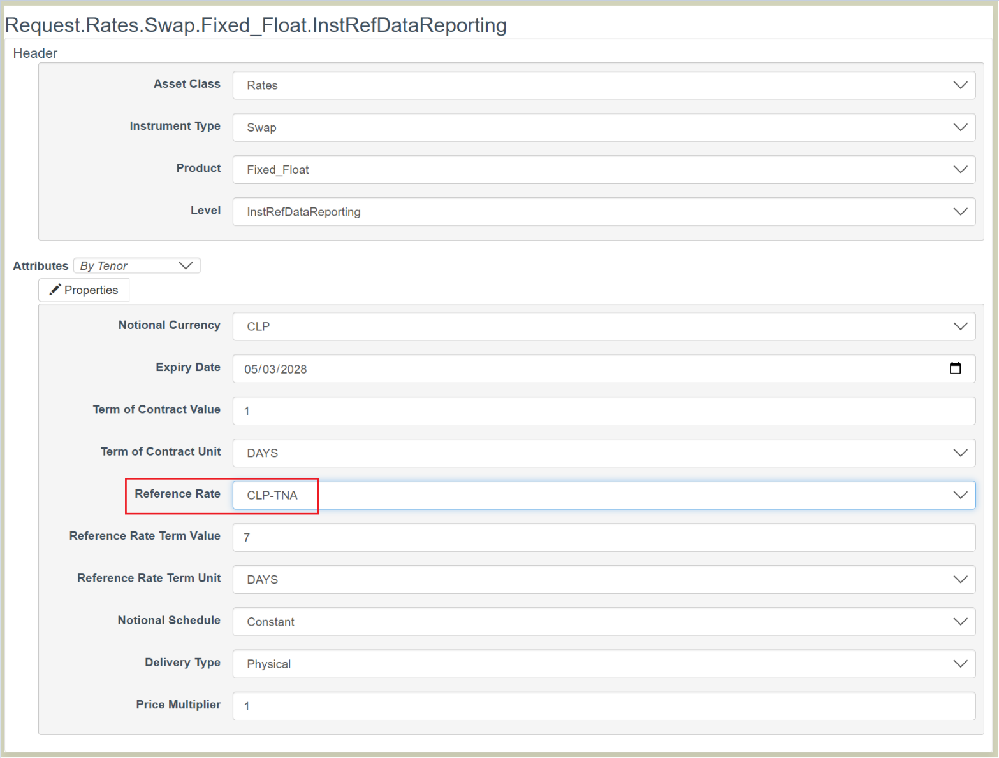

Sample of the GUI Record template:

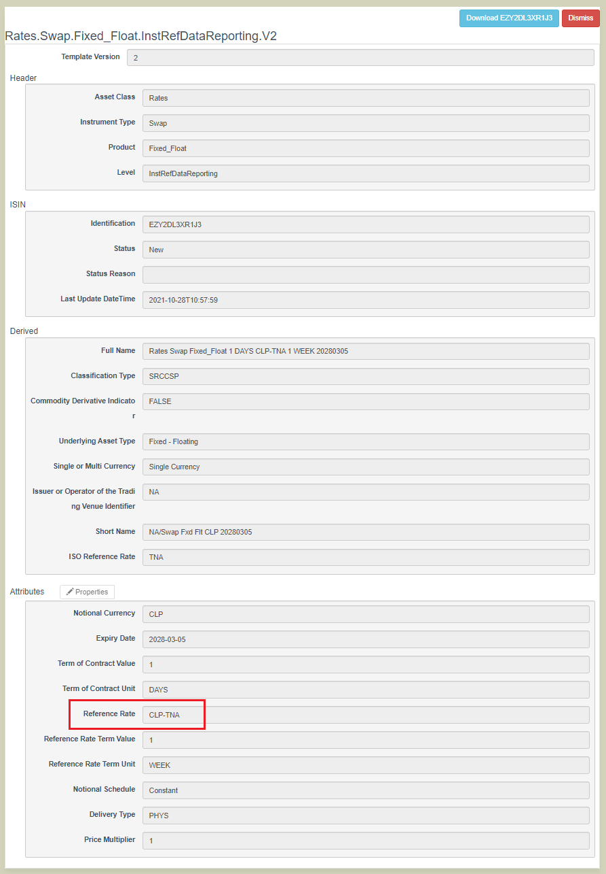

2nd Layout: Reference Rate that has one ISDA Definition (2006 or 2021)
Sample of the GUI Request template:
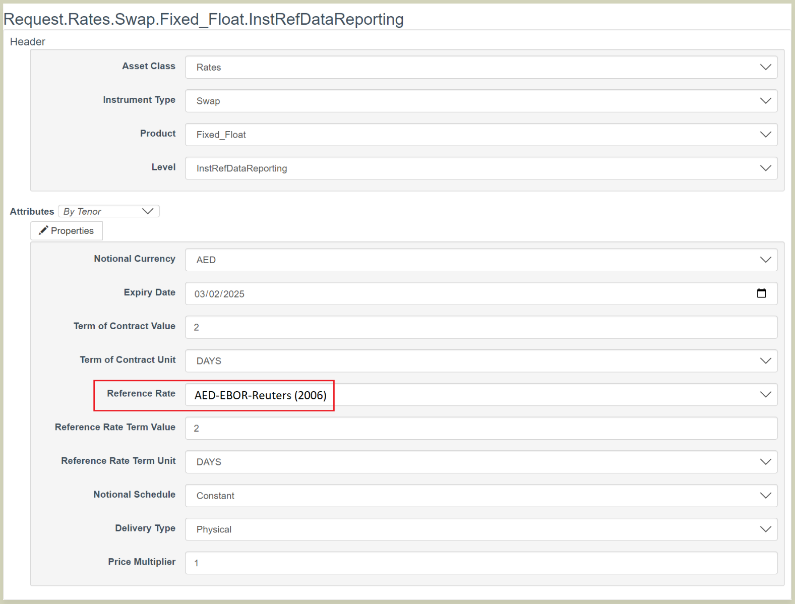

Sample of the GUI Record template:
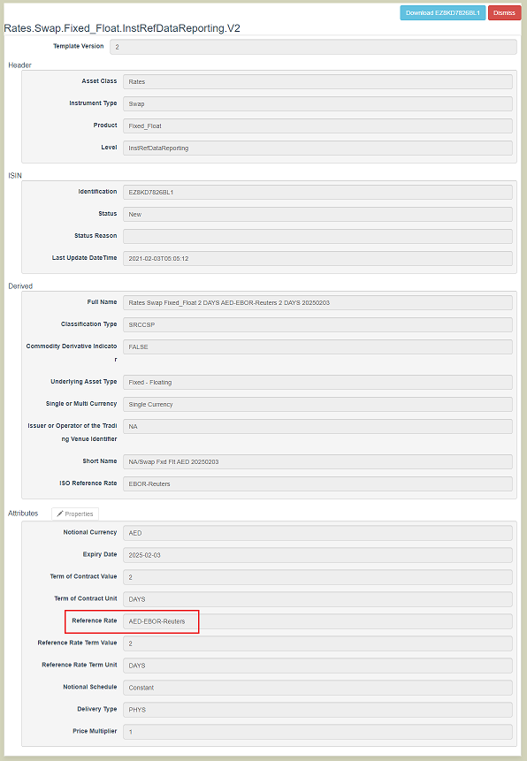

3rd Layout: Reference Rate that has two (2) ISDA Definitions (2006, 2021)

Sample of the GUI Request template:
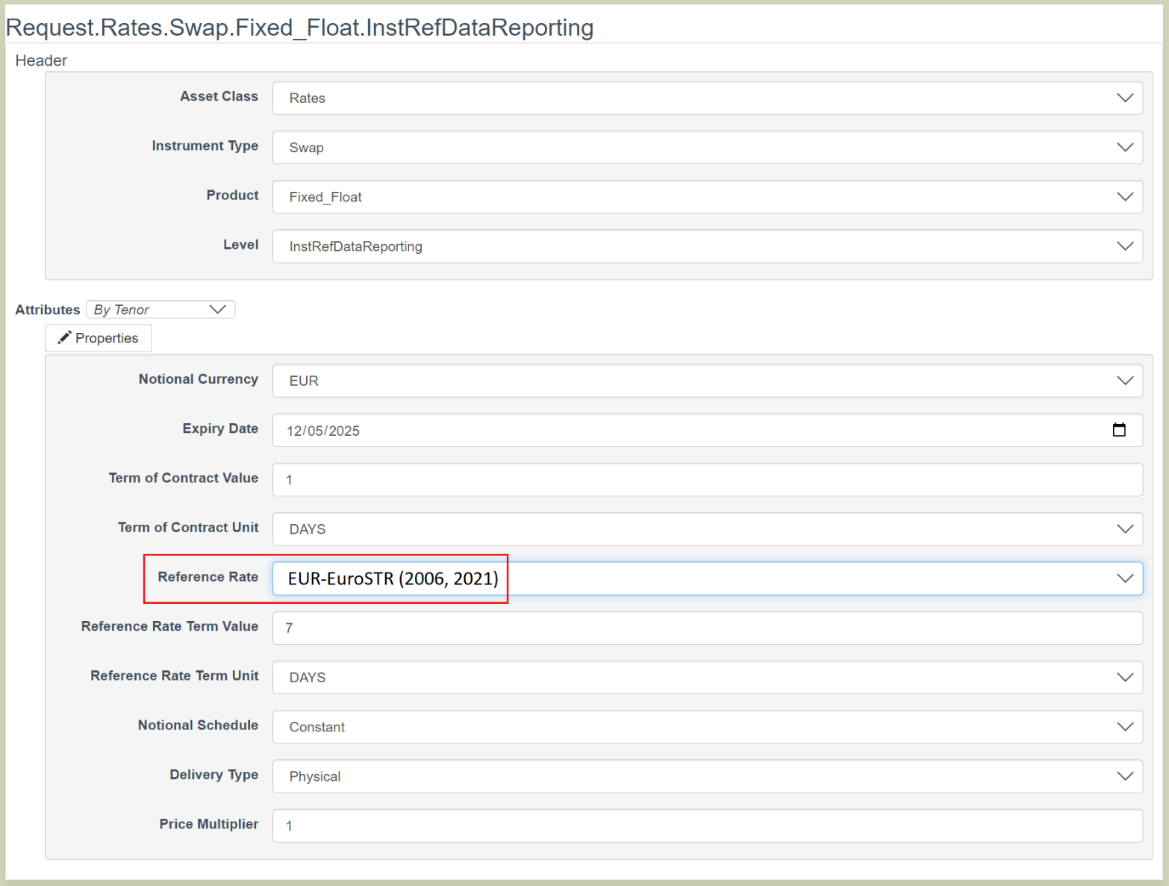

Sample of the GUI Record template:
