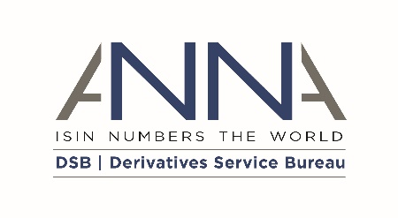
Derivatives Service Bureau (DSB) - ACCESS AND USAGE AGREEMENT
APPENDIX B – AMENDMENT TO AFFILIATES

DATE OF AMENDMENT |  | The date the last party signing the Agreement signed it (as specified next to its signature)
PARTIES
(1) | Derivatives Service Bureau (DSB) Ltd (Company No. 10542063), a company incorporated under the laws of England and Wales whose registered office is at Suite 21-23, 107 Cheapside, London, EC2V 6DN, United Kingdom, United Kingdom ("DSB"); and
(2) | [USER NAME], incorporated and registered in [INSERT JURIDSICTION] with company number [INSERT NUMBER] whose registered office is at [INSERT ADDRESS] (the "User") intends to use the DSB as a [SELECT DSB USER TYPE - INFREQUENT USER/ STANDARD USER / SEARCH ONLY API USER / POWER USER / POWER USER and INTERMEDIARY / INTERMEDIARY only],  each a "party" and together being the "parties".

INTRODUCTION
- The parties to the Agreement consent to a change in the list of Affiliates provided in Appendix B of the Main Terms (‘Appendix B Amendment’).
- This Appendix B Amendment forms part of the Agreement agreed between the User, its Affiliates and the DSB.
- Defined terms shall have the same meaning as set out in the main terms of the Agreement and as otherwise set out herein
- Affiliates entitled to the benefit of this Agreement, in accordance with the terms of the DSB User Policy, are listed in this Appendix B Amendment and shall replace the original Appendix B of the Main Terms.
- The DSB has agreed to allow the User to access and use the Data on behalf of itself and its Affiliates on the terms and conditions in the Agreement.

IN WITNESS WHEREOF this Amendment has been entered into on the date stated at the beginning of it.
Signed by ………………………………….:
For and on behalf of
DSB

Position: DSB Board Member
Date:

Signed by ………………………………….:
For and on behalf of
[USER NAME]

Position:
Date:
APPENDIX B AMENDMENT
AFFILIATES
- Categorisation of Affiliates as [SELECT CATEGORY – Asset Management Services / Wealth Management Services / Custodial Services / Clearing House / Data Management Services / Investment Bank]

