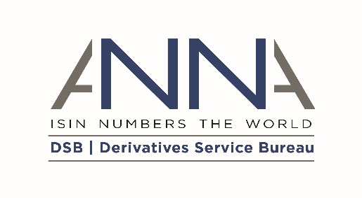
DSB BT RADIANZ™ User Addendum to
the DSB Access and Usage Agreement

ADDENDUM EFFECTIVE DATE |  | [INSERT DATE], notwithstanding the date of signature
PARTIES
(1) | Derivatives Service Bureau (DSB) Ltd (Company No. 10542063), a company incorporated under the laws of England and Wales whose registered office is at Suite 21-23, 107 Cheapside, London, EC2V 6DN, United Kingdom ("DSB"); and
(2) | [USER NAME], incorporated and registered in [INSERT JURISDICTION] with company number [INSERT NUMBER] whose registered office is at [INSERT ADDRESS] (the "User") wished to upgrade its service to include BT Radianz™ connectivity, each a "party" and together being the "parties".

- INTRODUCTION
  - The parties entered into the DSB’s Access and Usage Agreement dated [INSERT DATE] (“Agreement”) pursuant to which the User is permitted to access the DSB Service and Data.
  - The DSB offers an optional service enabling users with programmatic access to connect to the DSB Service using connectivity provided by BT Radianz™ (“BT Radianz™ Service”). The User wishes to make use of the BT Radianz™ Service and the DSB has agreed to enable such use on the terms of the Agreement, as amended by this Addendum.
  - Defined terms used in this Addendum shall have the same meaning as set out in the Main Terms of the Agreement or the Policies (as applicable) and as otherwise set out herein. Unless the context otherwise requires, the rules of interpretation set out in the Agreement shall apply to this Addendum as if set out in this Addendum, except that references in those rules to "this Agreement" shall be construed as references to this Addendum.
  - With effect from the Addendum Effective Date, the Agreement is amended to include the provisions in clause 2 (BT Radianz™ Service Terms).
- BT RADIANZ™ SERVICE TERMS
  - From the Addendum Effective Date and for the remainder of the Term of the Agreement (subject to clause 2.10) the DSB will enable the User to connect to the DSB Service via the BT Radianz™ Service, as more fully described at https://www.anna-dsb.com/optional-services/ (or an alternative location notified by the DSB from time to time).
  - Use of the BT Radianz™ Service is dependent upon the User having its own BT Radianz™ connection via a direct agreement between the User and BT Radianz™, which the User must maintain for the duration of the Term. The DSB shall have no liability for any inability to access the BT Radianz™ Service due to the User not having a BT Radianz™ connection, or for any reasons attributable to the underlying service provided by BT Radianz™.
  - If required by BT Radianz™, use of the BT Radianz™ Service may be subject to additional terms of use. The DSB will notify the User if any such additional terms become applicable. If the User objects to the additional terms, it may terminate the Agreement with respect to the BT Radianz™ Service by written notice to the DSB, given within 30 days of the DSB’s notification of the additional terms and receive a refund of any Management Fees paid in advance for full calendar months in the period after termination. If no such notice is given, the User undertakes to comply with the additional terms.
  - The following Fees shall apply to the User’s access to the BT Radianz™ Service as at the Addendum Effective Date:

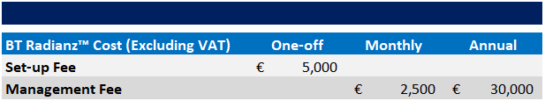

The Management Fee is a monthly Fee of €2,500 but is payable annually in advance.
  - The DSB may amend the Fees in paragraph 2.4 once annually, on written notice to User given at least 90 days before expiry of the Initial Invoicing Period or Invoicing Period (as applicable).
  - [DRAFTING NOTE: use this clause only for Addenda that are being backdated.] As at the Addendum Effective Date:
    - the User has paid the Set-up Fee;
    - the User has paid the Management Fee for the period between the Addendum Effective Date and [insert date].
  - [DRAFTING NOTE: use this clause for new Users signing up to BT Radianz™] Within 14 calendar days of the Addendum Effective Date, the DSB shall invoice the User for the Set-up Fee and the first annual Management Fee, pro-rated on a daily basis from the Addendum Effective Date until the end of the current Initial Invoicing Period or Invoicing Period (as applicable).
  - The DSB shall invoice the User for the annual Management Fee for the remainder of the Term at the start of the Initial Invoicing Period (if applicable) and each subsequent Invoicing Period.
  - Invoices shall be payable in accordance with clause 9.6 set out in the DSB Access and Usage Agreement. All other provisions of the DSB Charges Policy shall continue to apply with respect to the DSB Service.
  - The User’s access to the BT Radianz™ Service shall terminate automatically on termination of the Agreement for any reason. In addition:
    - either party may elect not to renew the Agreement with respect to the BT Radianz™ Service in accordance with clause 2.2 of the Main Terms;
    - the DSB may terminate the Agreement with respect to BT Radianz™ Service if the DSB’s agreement with BT Radianz™ terminates for any reason or if BT Radianz™ changes its underlying service in a manner which prevents the DSB from providing the BT Radianz™ Service. The DSB will endeavour to provide the User with advance notice depending on the circumstances of termination.
- MISCELLANEOUS
  - The Agreement (as amended by this Addendum) shall remain in full force and effect. In addition, the following provisions of the Agreement apply specifically to the BT Radianz™ Service as if references to the “DSB Service” in those provisions were references to the “BT Radianz™ Service”:
    - clauses 1.3, 1.6, 1.7, 3.2, 3.4, 3.5, 3.6, 3.8, 4.4, 5, 8.2, 8.6, 9, 14, 15 and 16 of the Main Terms (and defined terms used in these clauses);
    - paragraphs 1, 2.4 and 2.5 of the DSB Acceptable Use Policy;
    - DSB Governance Policy.
  - No one other than a party to this Addendum, their successors and permitted assignees, shall have any right under the Contracts (Rights of Third Parties) Act 1998 to enforce any of its terms.
  - This Addendum may be executed in any number of counterparts, each of which when executed shall constitute a duplicate original, but all the counterparts shall together constitute the one Addendum.
  - This Addendum and the Agreement (as amended from time to time) constitutes the entire agreement and understanding between the parties in respect of the access and use of the DSB Service and supersedes any previous agreement between the parties relating to such matter.
  - This Addendum and any dispute or claim arising out of or in connection with it or its subject matter or formation (including non-contractual disputes or claims) shall be governed by and construed in accordance with the laws of England and Wales. Any dispute arising out of or in connection with this Addendum shall be resolved in accordance with paragraphs 4 and 5 of the Governance Policy.

IN WITNESS WHEREOF this Addendum has been entered into on the date of signature by the last party signing it.

Signed by ………………………………….:
For and on behalf of
DSB

Position: DSB Board Member
Date:

Signed by ………………………………….:
For and on behalf of
[USER NAME]

Position:
Date:

